# Java SE Project

Training & Placement

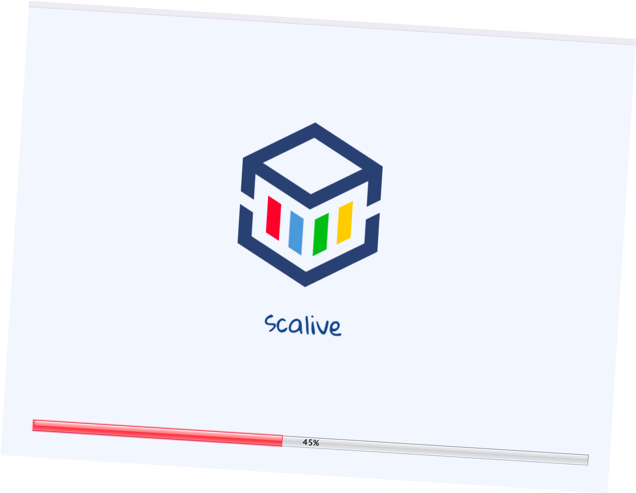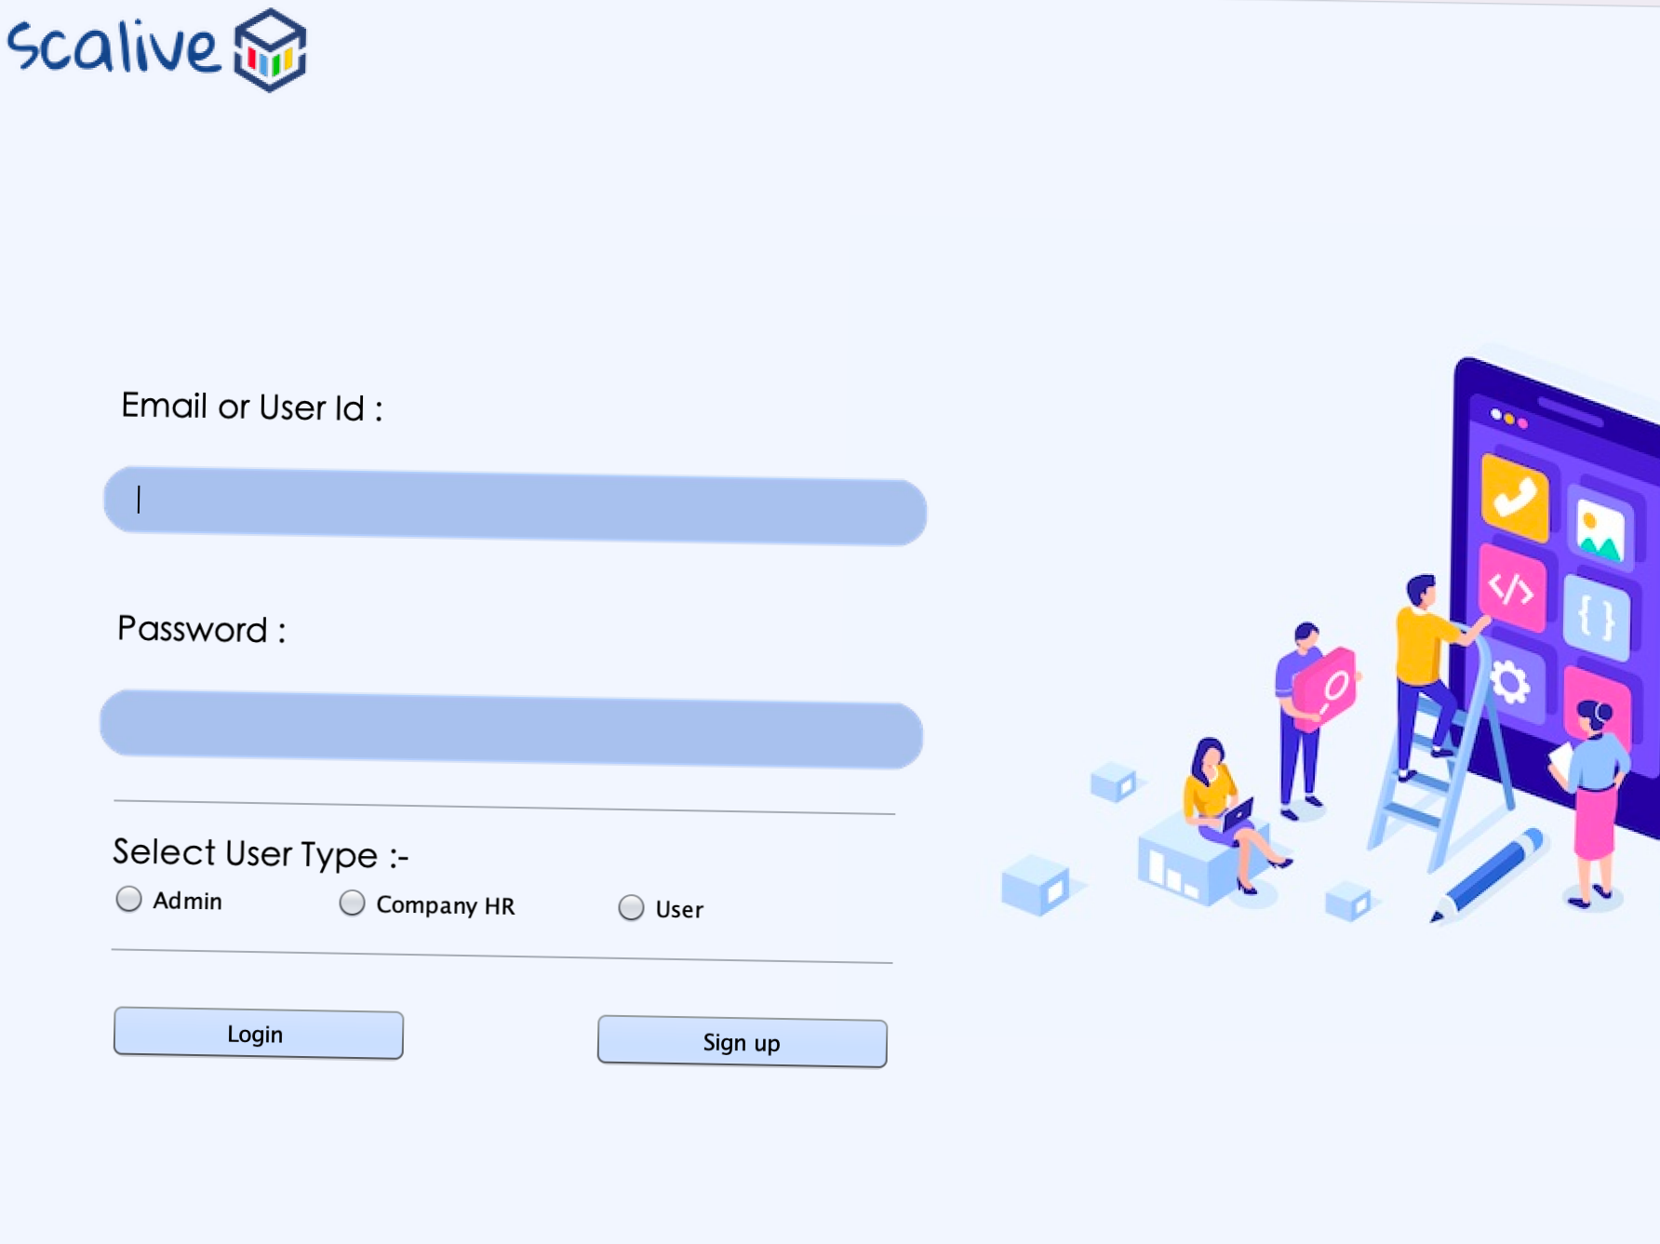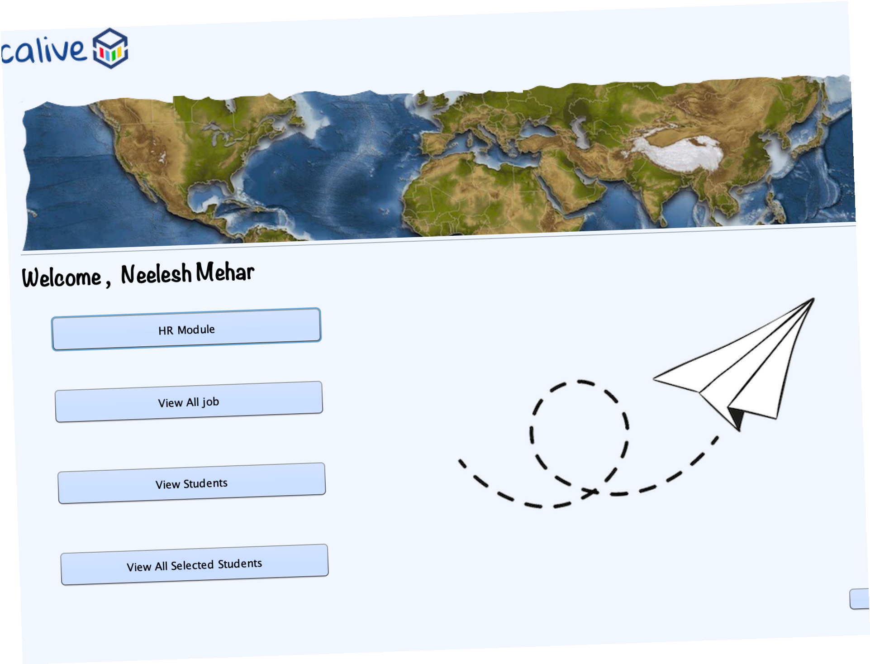

n this project we have create a generic application for all companies , they will use our platform and register their self and according to their requirements they will create job and as well as the technical round or

aptitude round for the user or participants. So It will be easy for the user as well as for the Companies to appear in exams and take quiz respectively .

# Total Frames in the Training & Placement App

Over all , the project “ Training & Placement ” , will have following frames :-

❄ The Project contains 4 main module -

✶ Login Module

✶ Admin Module

✶ HR Module

✶ Participants Module

## ✶ Login Module -

✶ SplashScreen

✶ SignUpFrame

✶ LoginFrame

## ✶ Admin Module -

✶ AdminOptionFrame

✶ AdminHrModuleFrame

✶ AdminAddNewHrFrame

✶ AdminModifyHrFrame

✶ AdminRemoveHrFrame

✶ AdminViewAllHrFrame

✶ AdminViewAllJobFrame

✶ AdminViewAllParticipantsFrame

✶ AdminViewAllSelectedParticipantsFrame

## ✶ Hr Module -

✶ HrOptionFrame

✶ HrJobOptionFrame

✶ HrAddNewJobFrame

✶ HrAddNewJobFrame

✶ HrEditJobFrame & HrEditJobFrame1

✶ HrRemoveJobFrame

✶ HrQuizOptionFrame

✶ HrSetPaperFrame & HrSetPaperFrame1

✶ HrEditQuizFrame & HrEditQuizFrame1

✶ HrViewAllOpenJobFrame

✶ HrViewAllParticipantsFrame

✶ HrViewAllQualifiedParticipantsFrame

## ✶ Participants Module -

✶ ParticipantsOptionFrame

✶ PtEditProfileFrame

✶ PtViewAllJobFrame

✶ PtAllPendingJobFrame

✶ PtAllCompletedJobFrame

✶ PtTakeQuizFrame

# Some snapshots of Training & Placement App

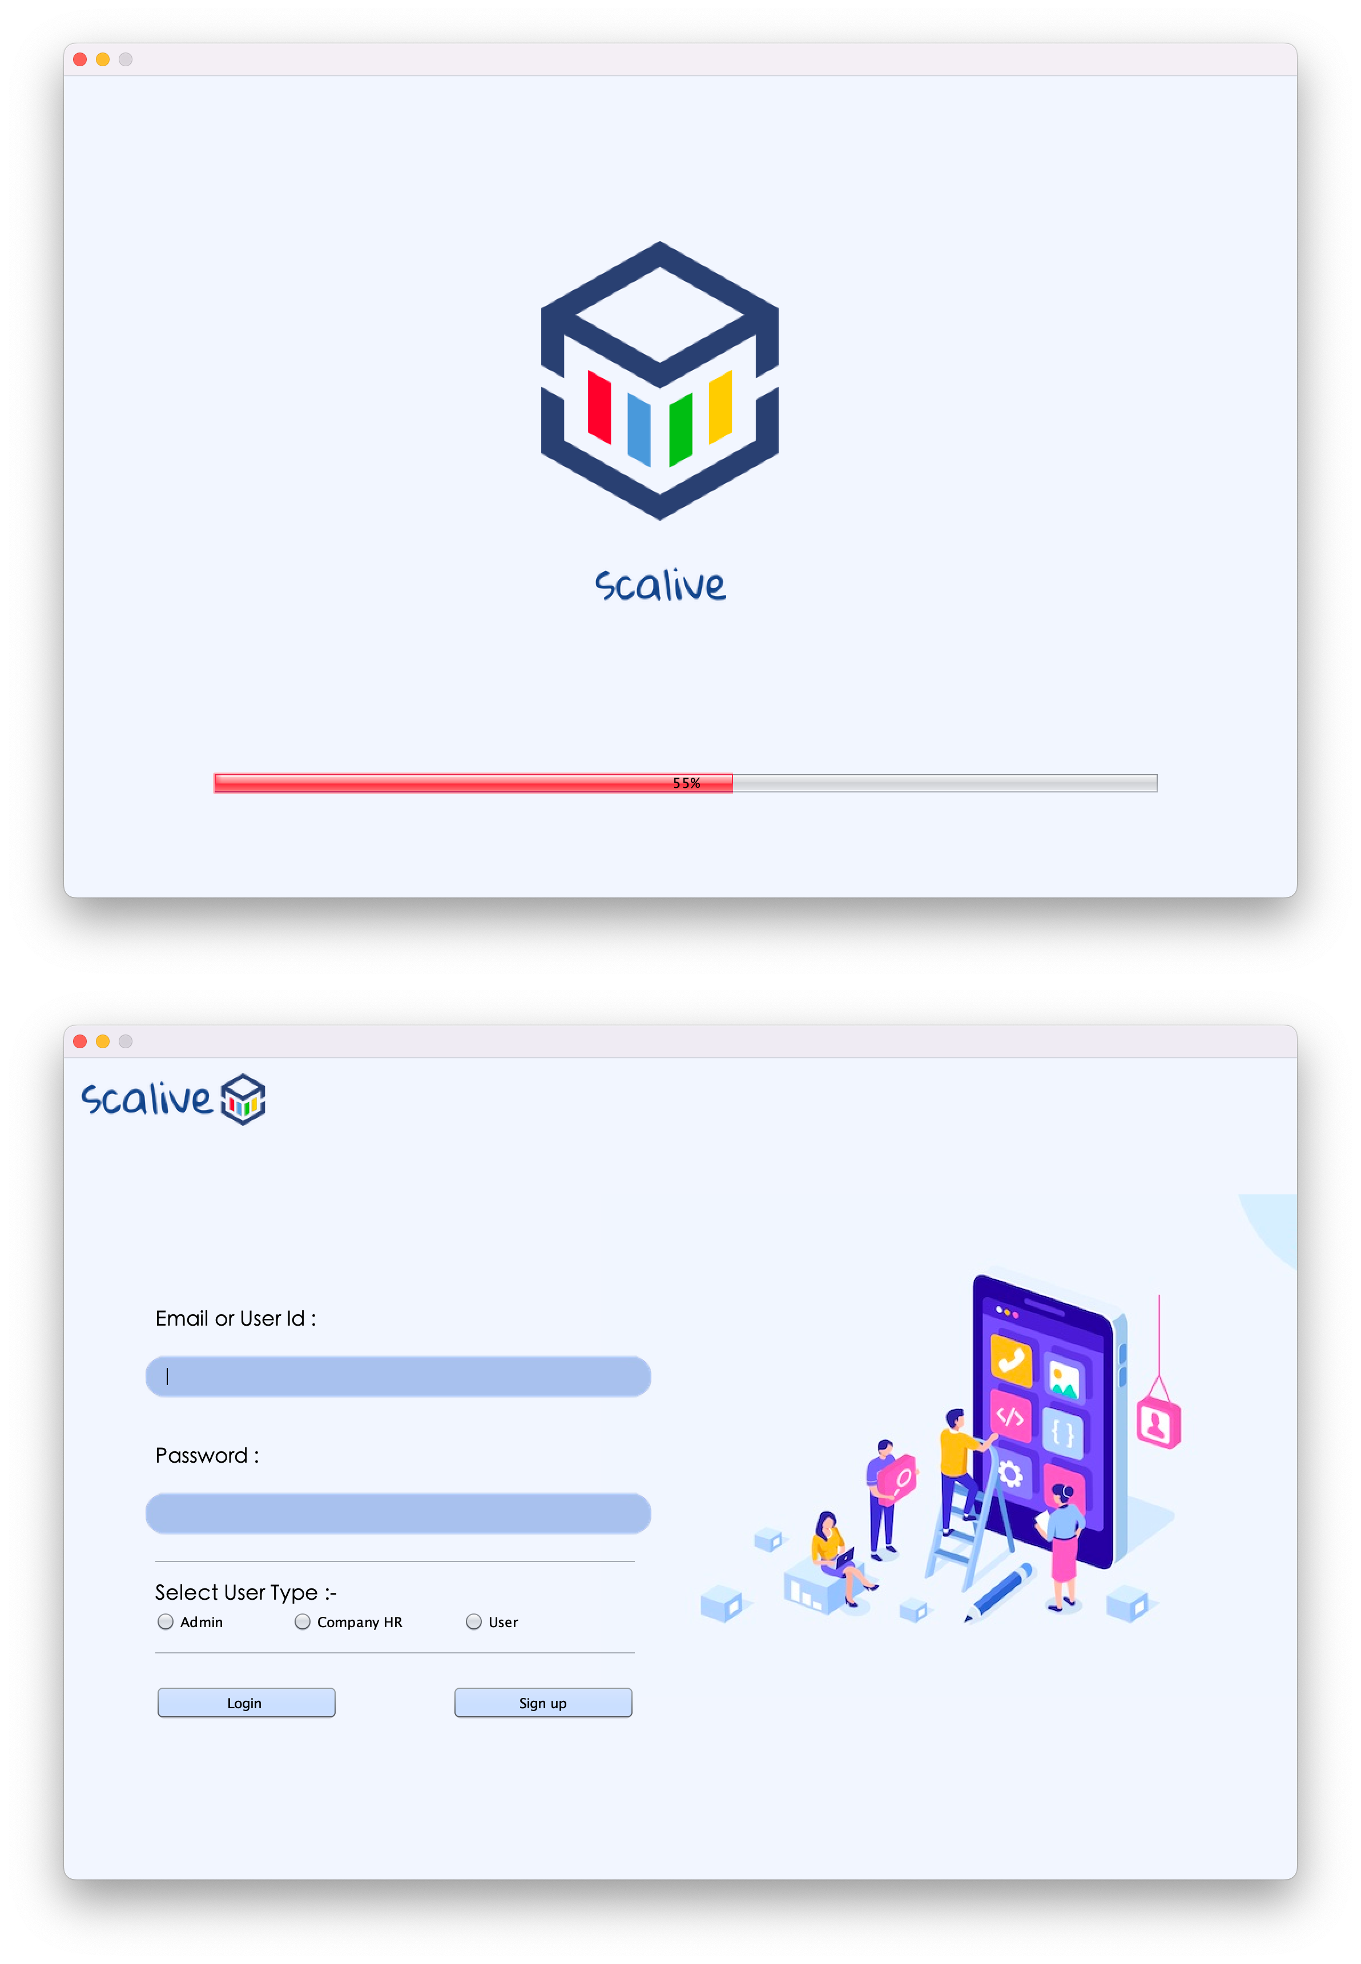

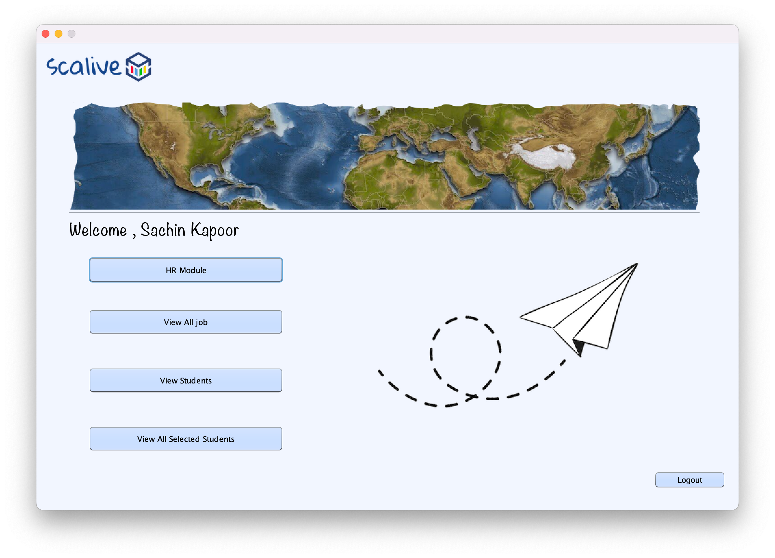

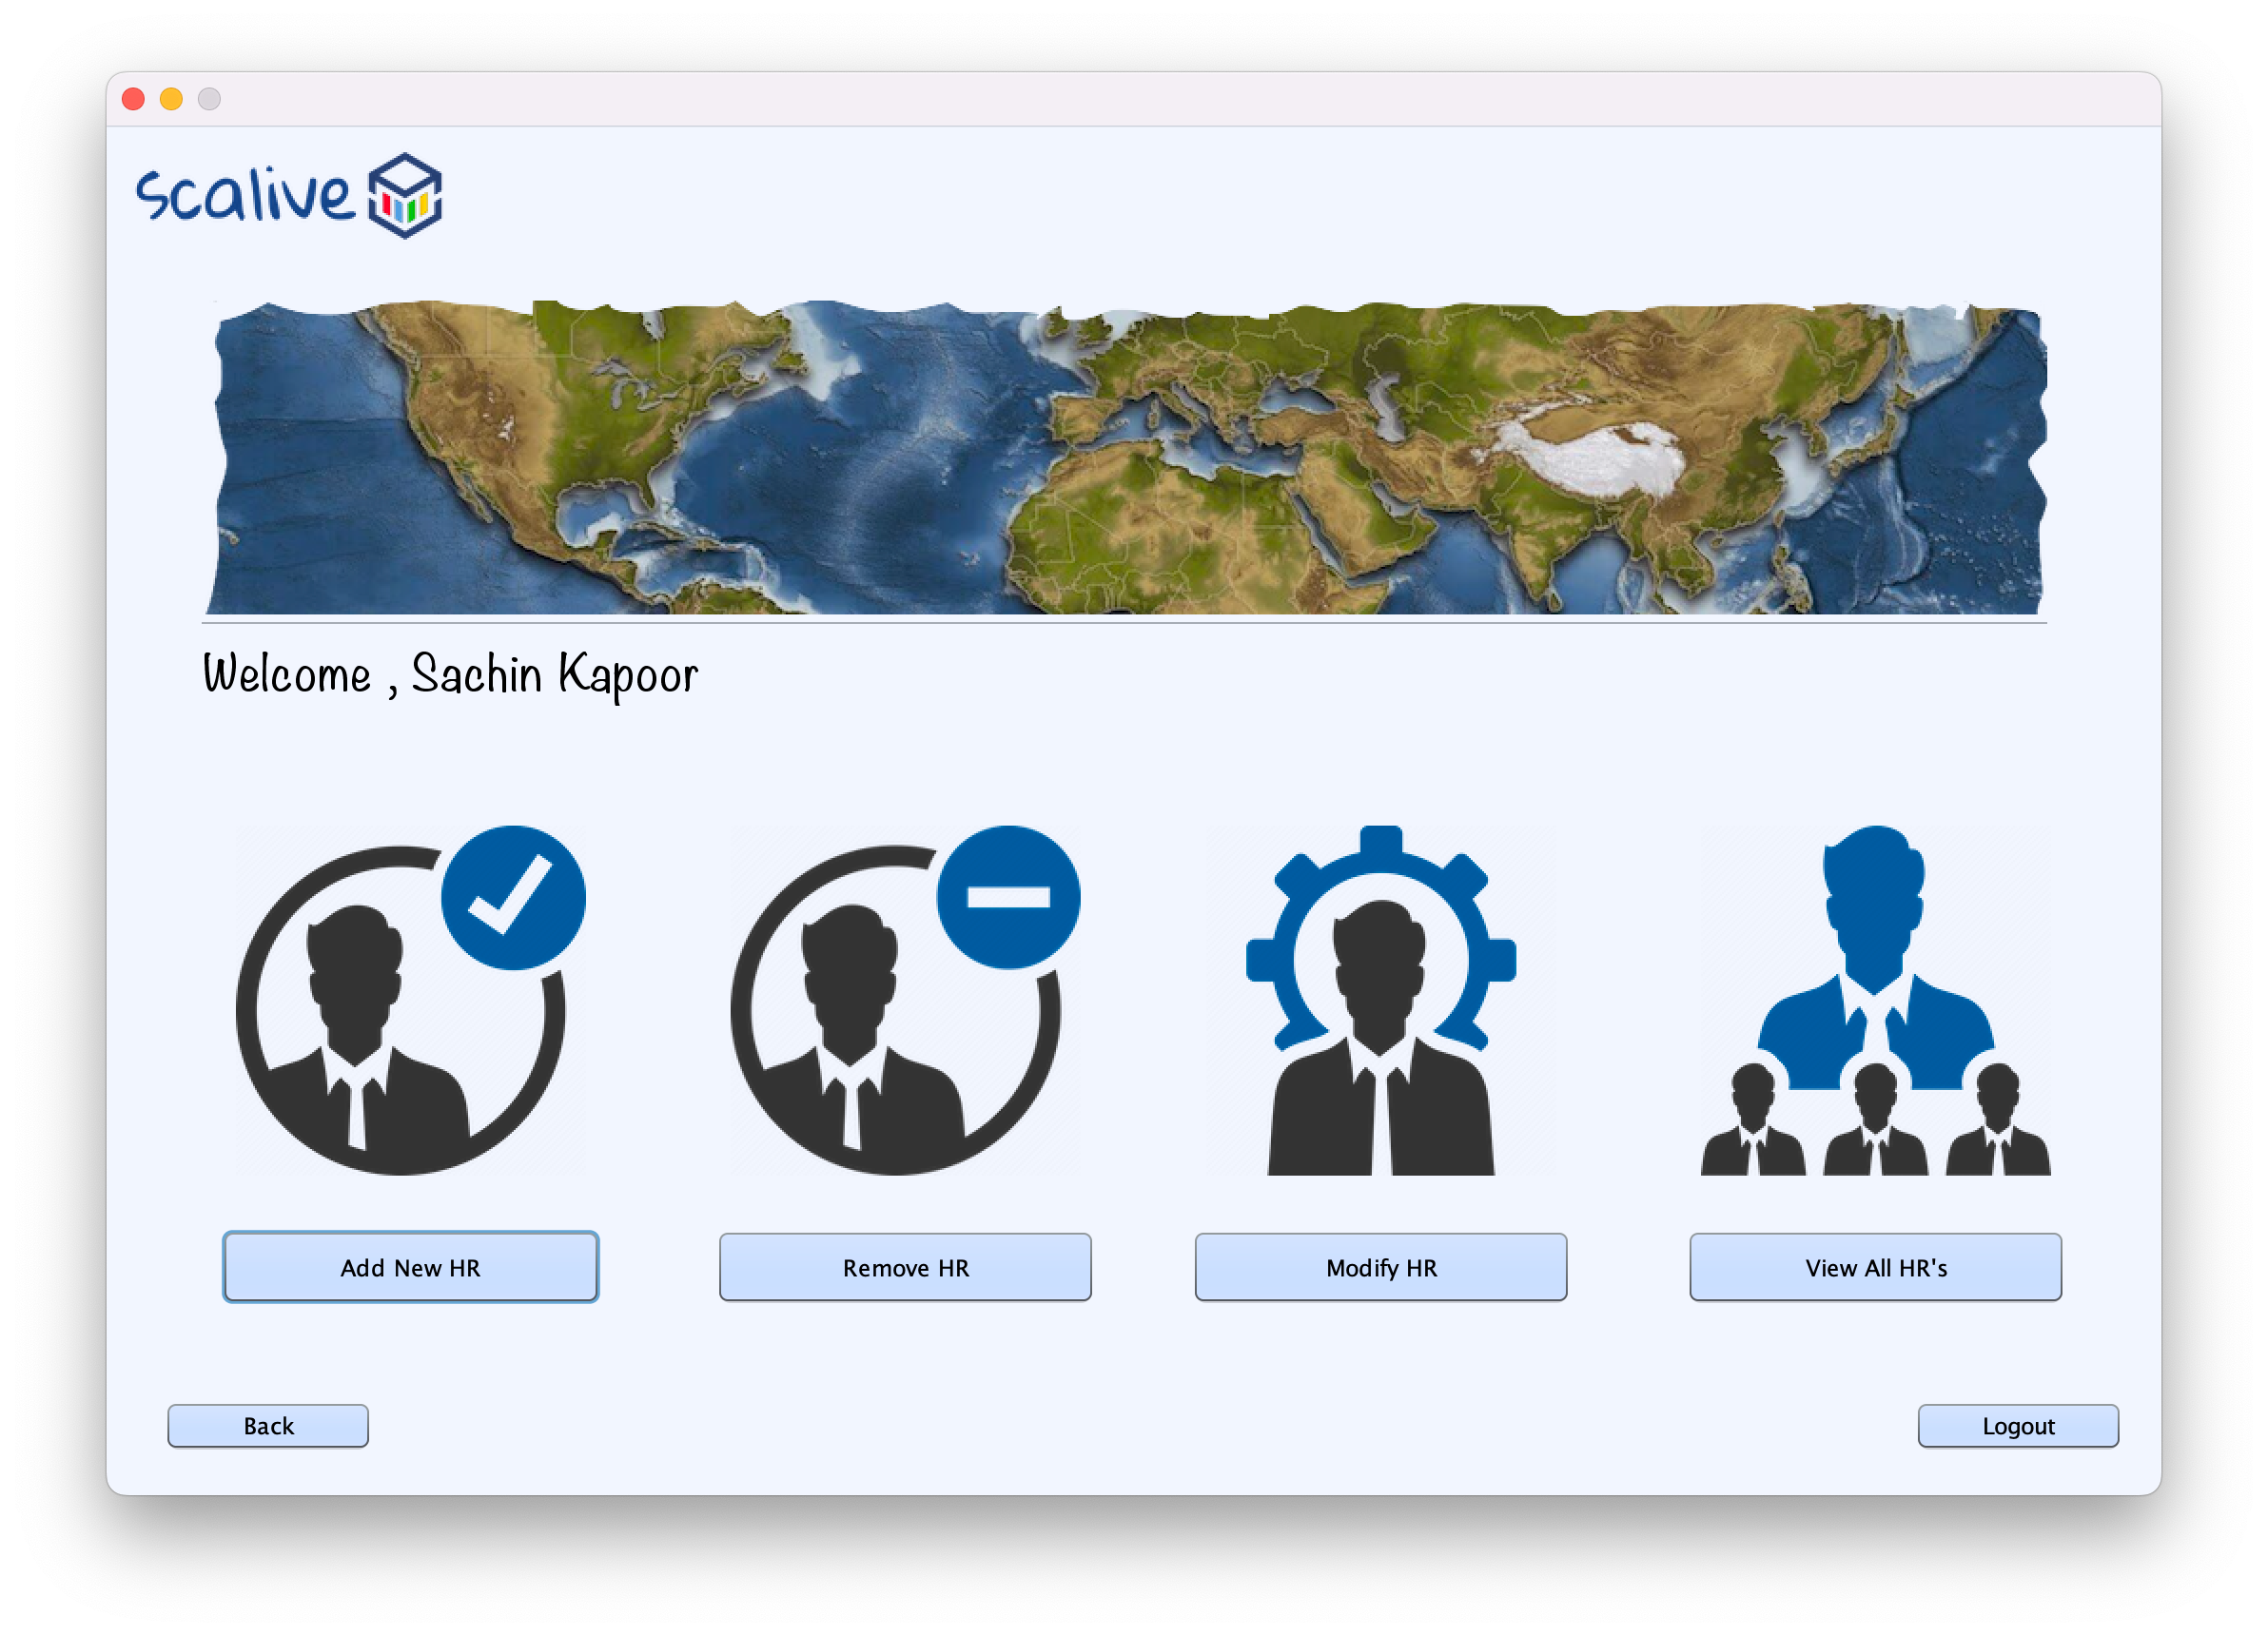Admin Option Frame

Admin Hr Module Frame

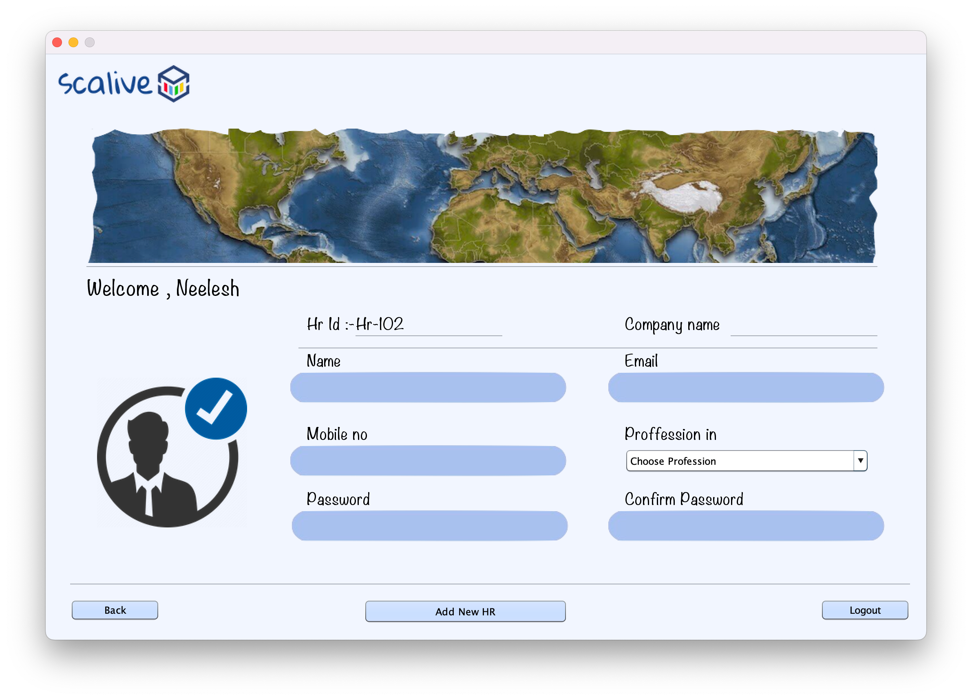

Admin Add New HR Frame

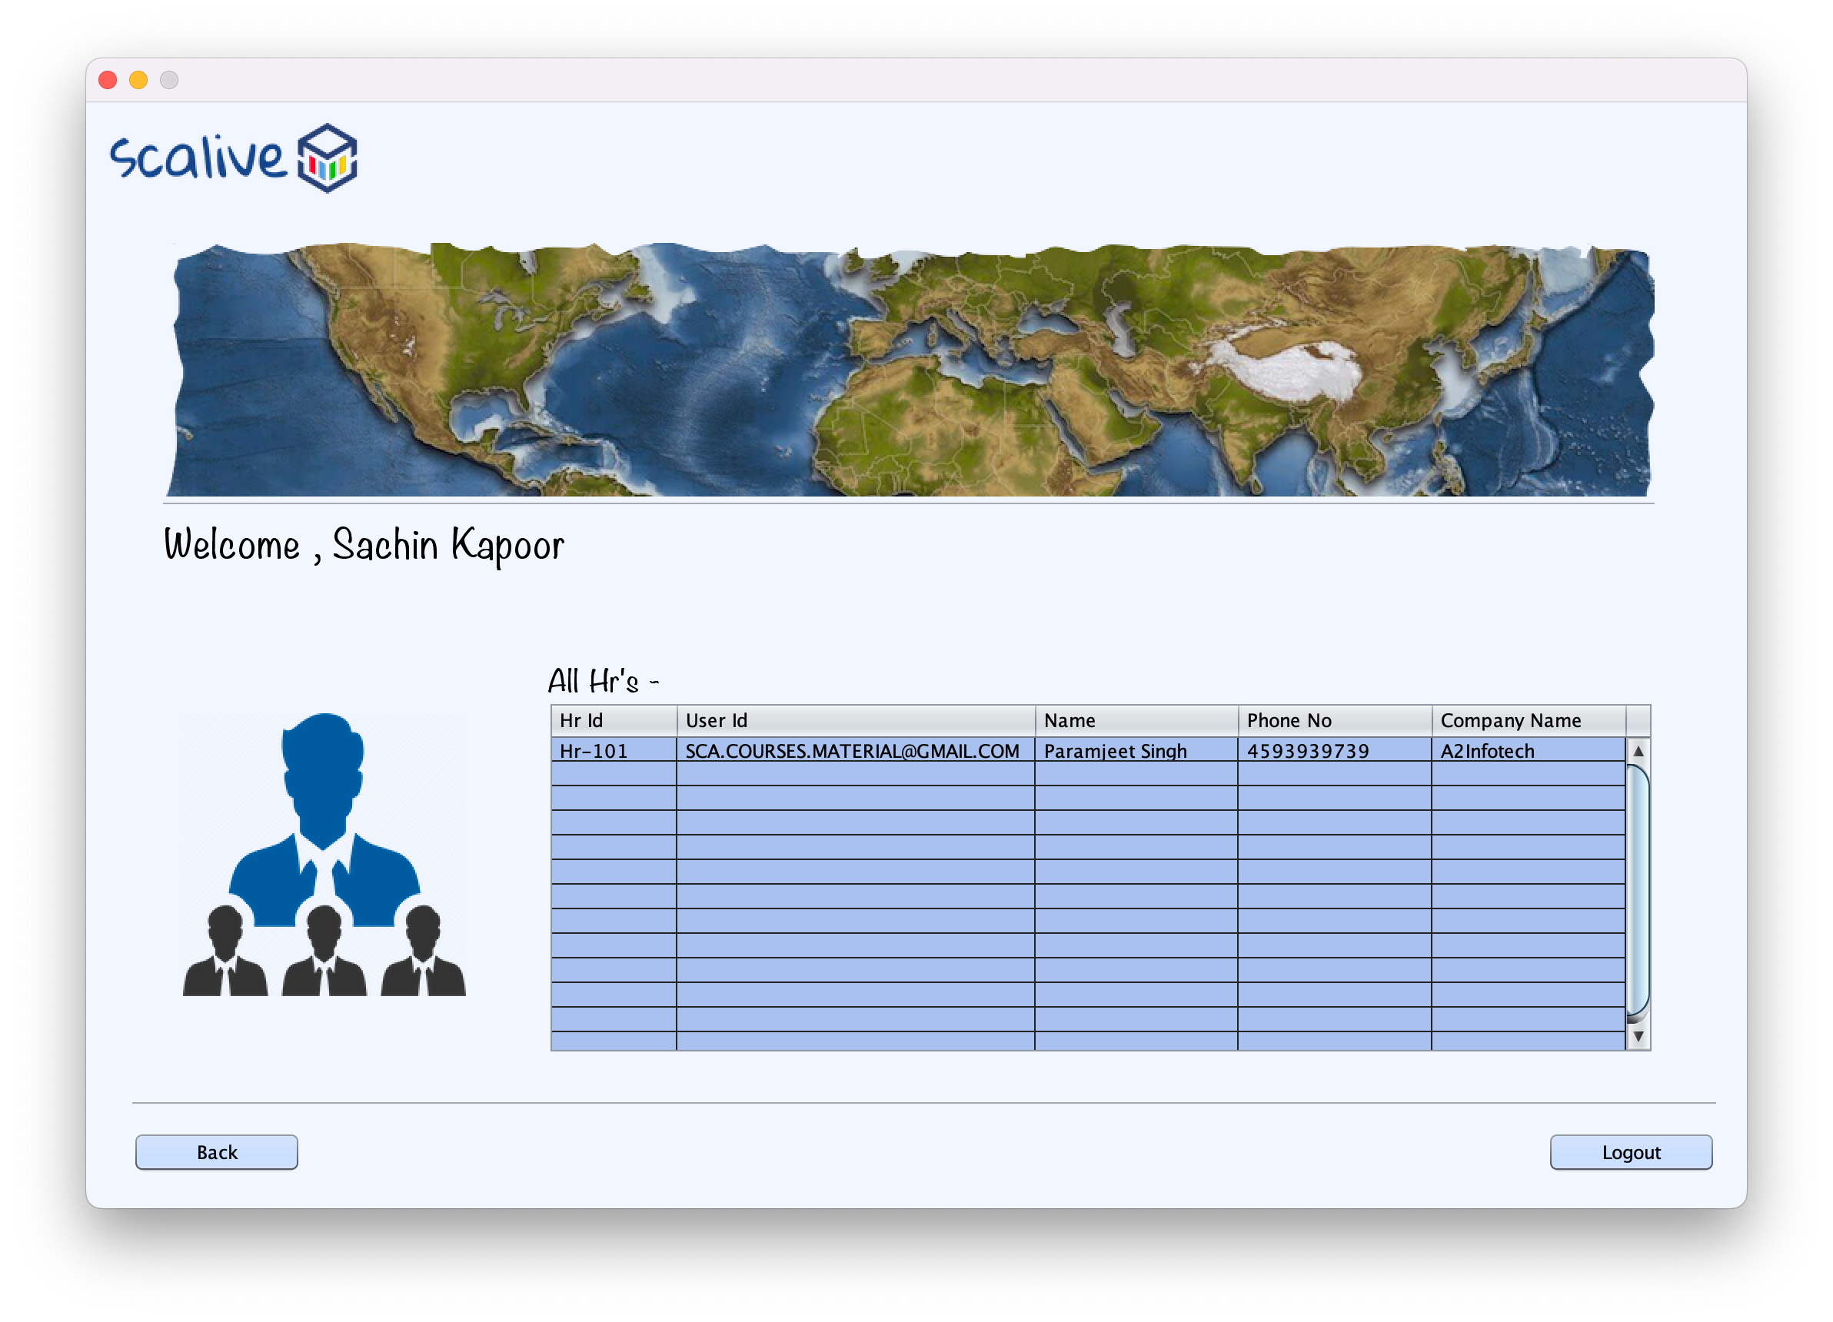

Admin View All HR Frame

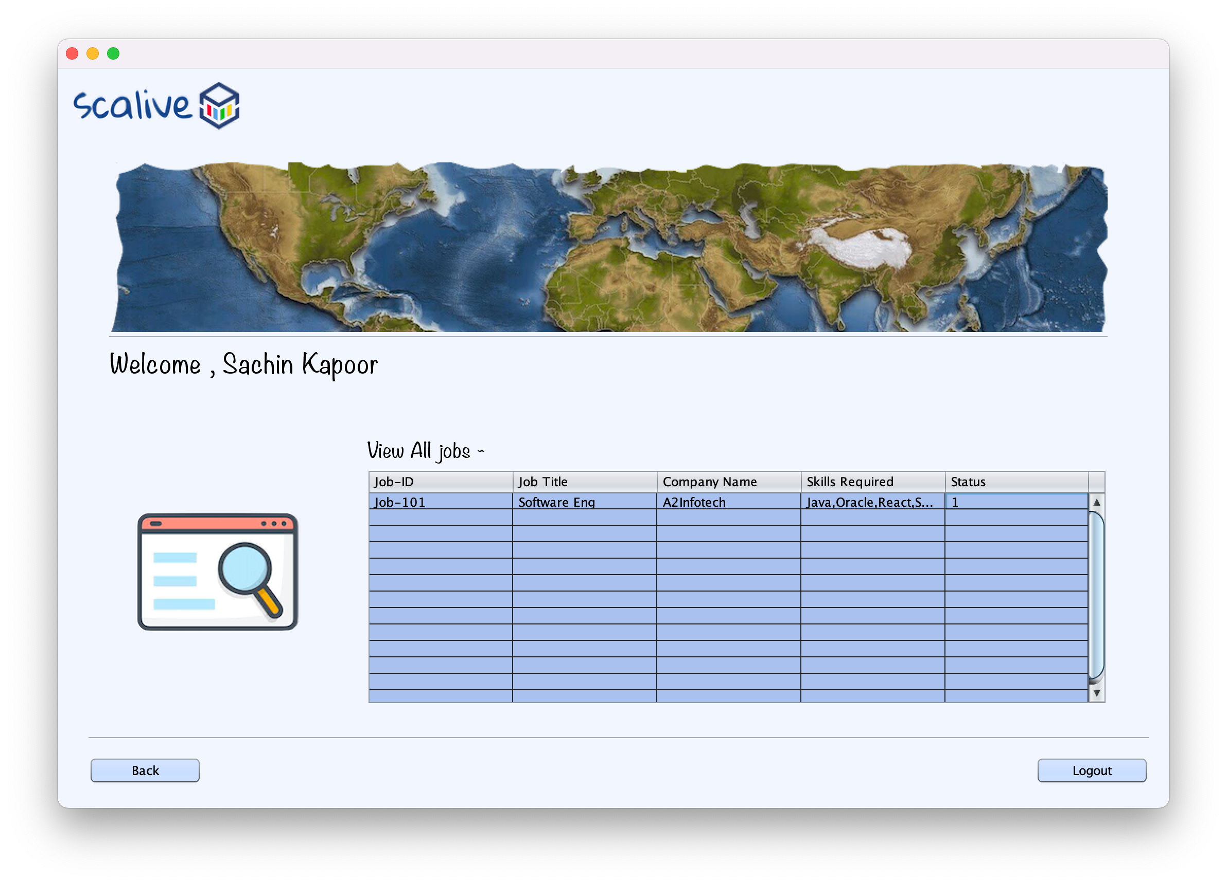

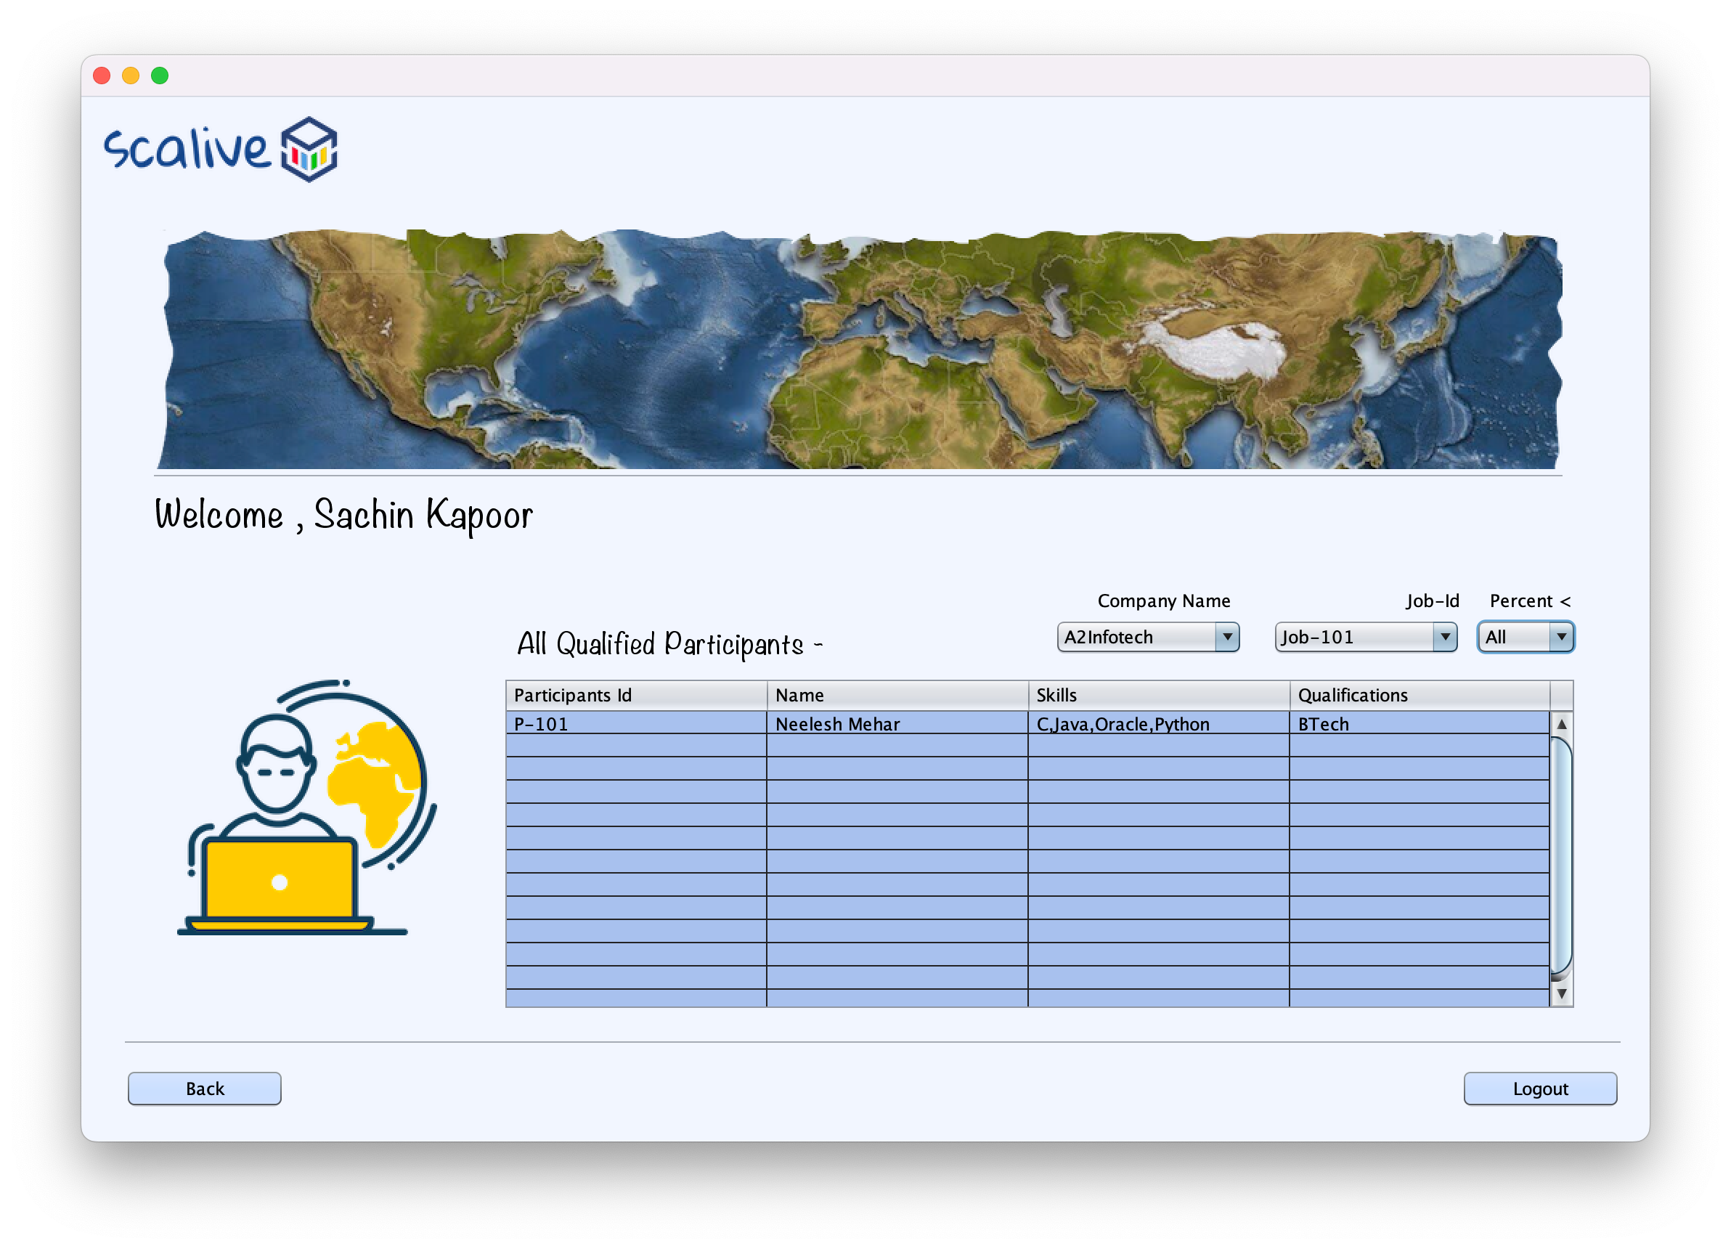Admin View All Job Frame

Admin View all qualified participants frame

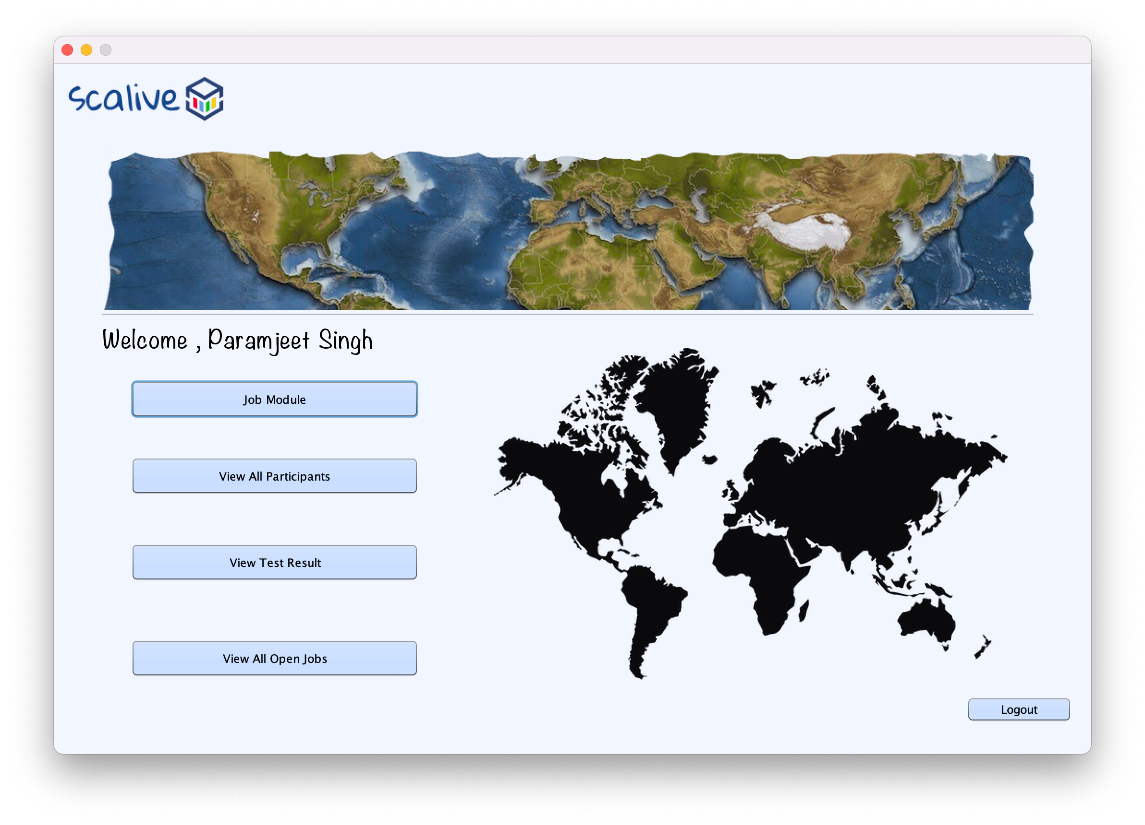

Hr Options Frame

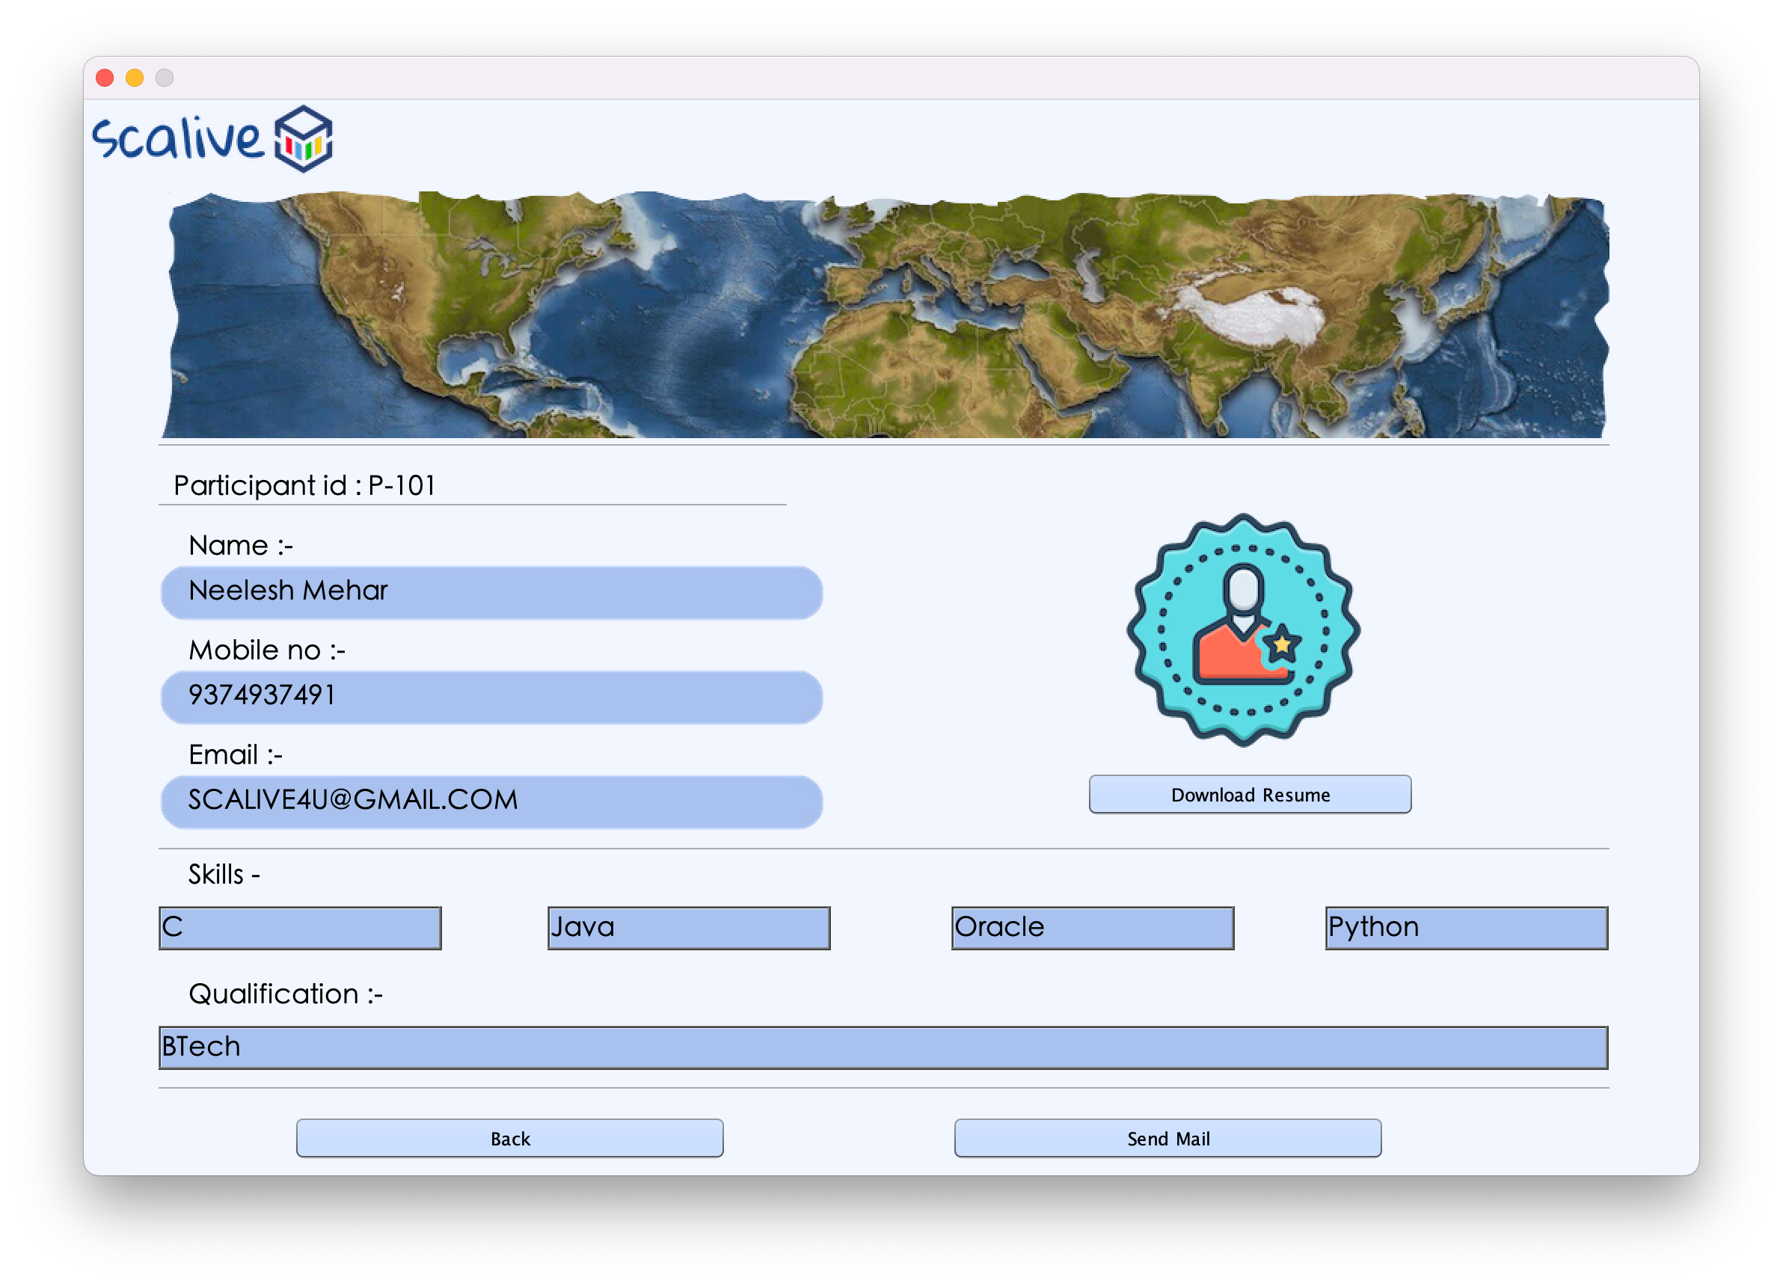

Hr view participants frame

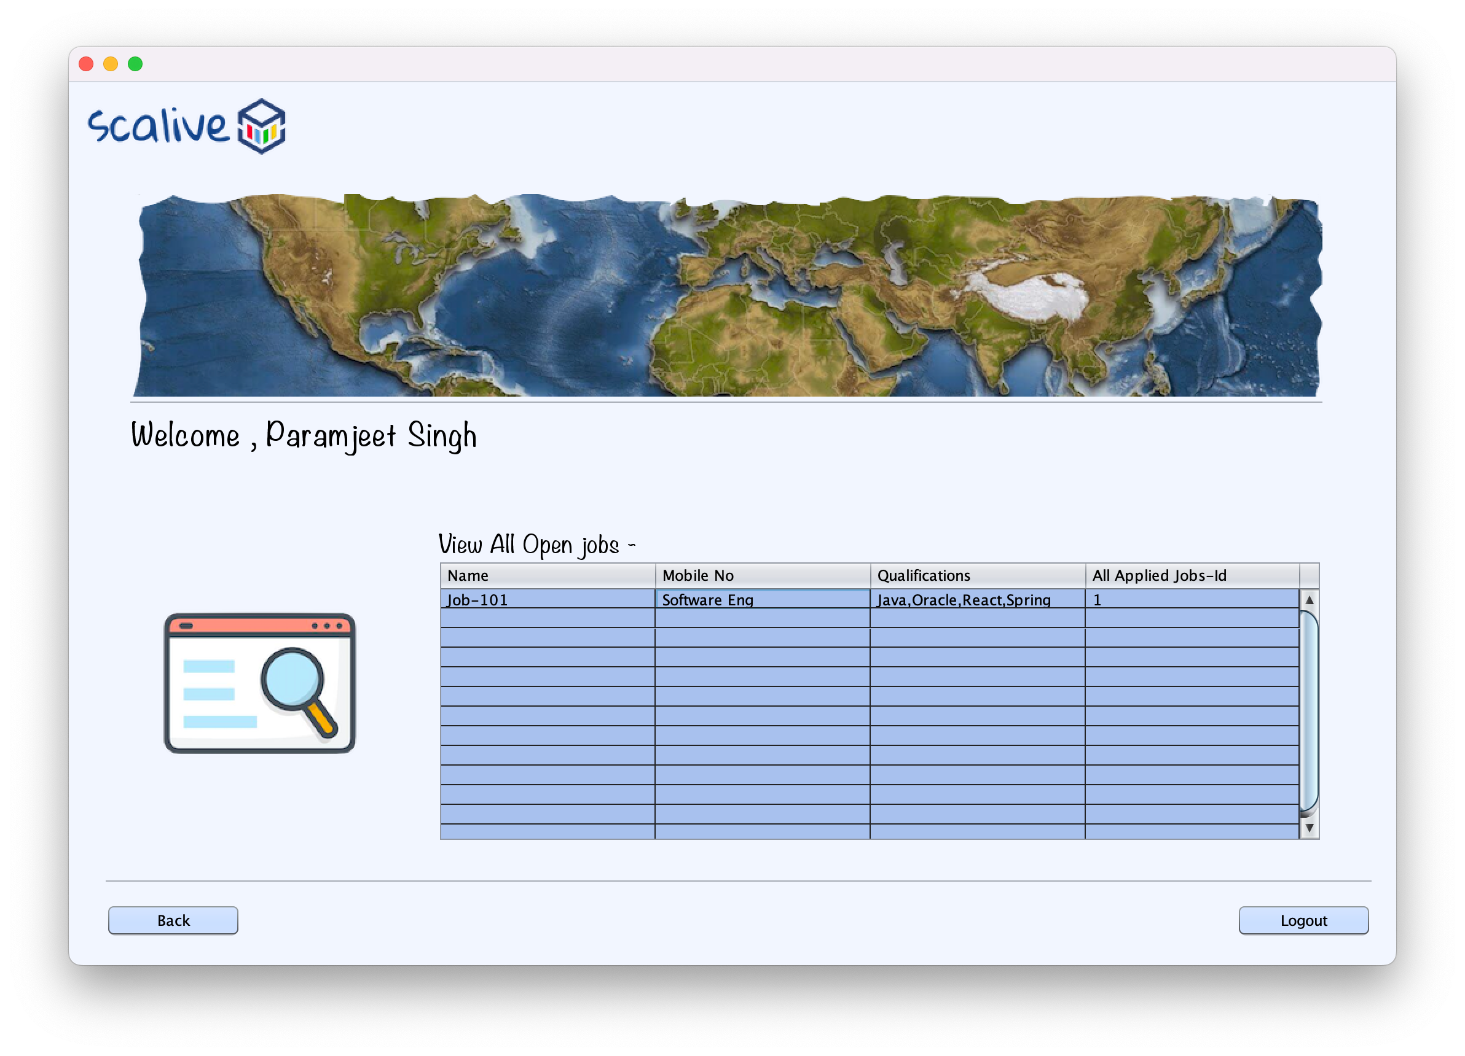

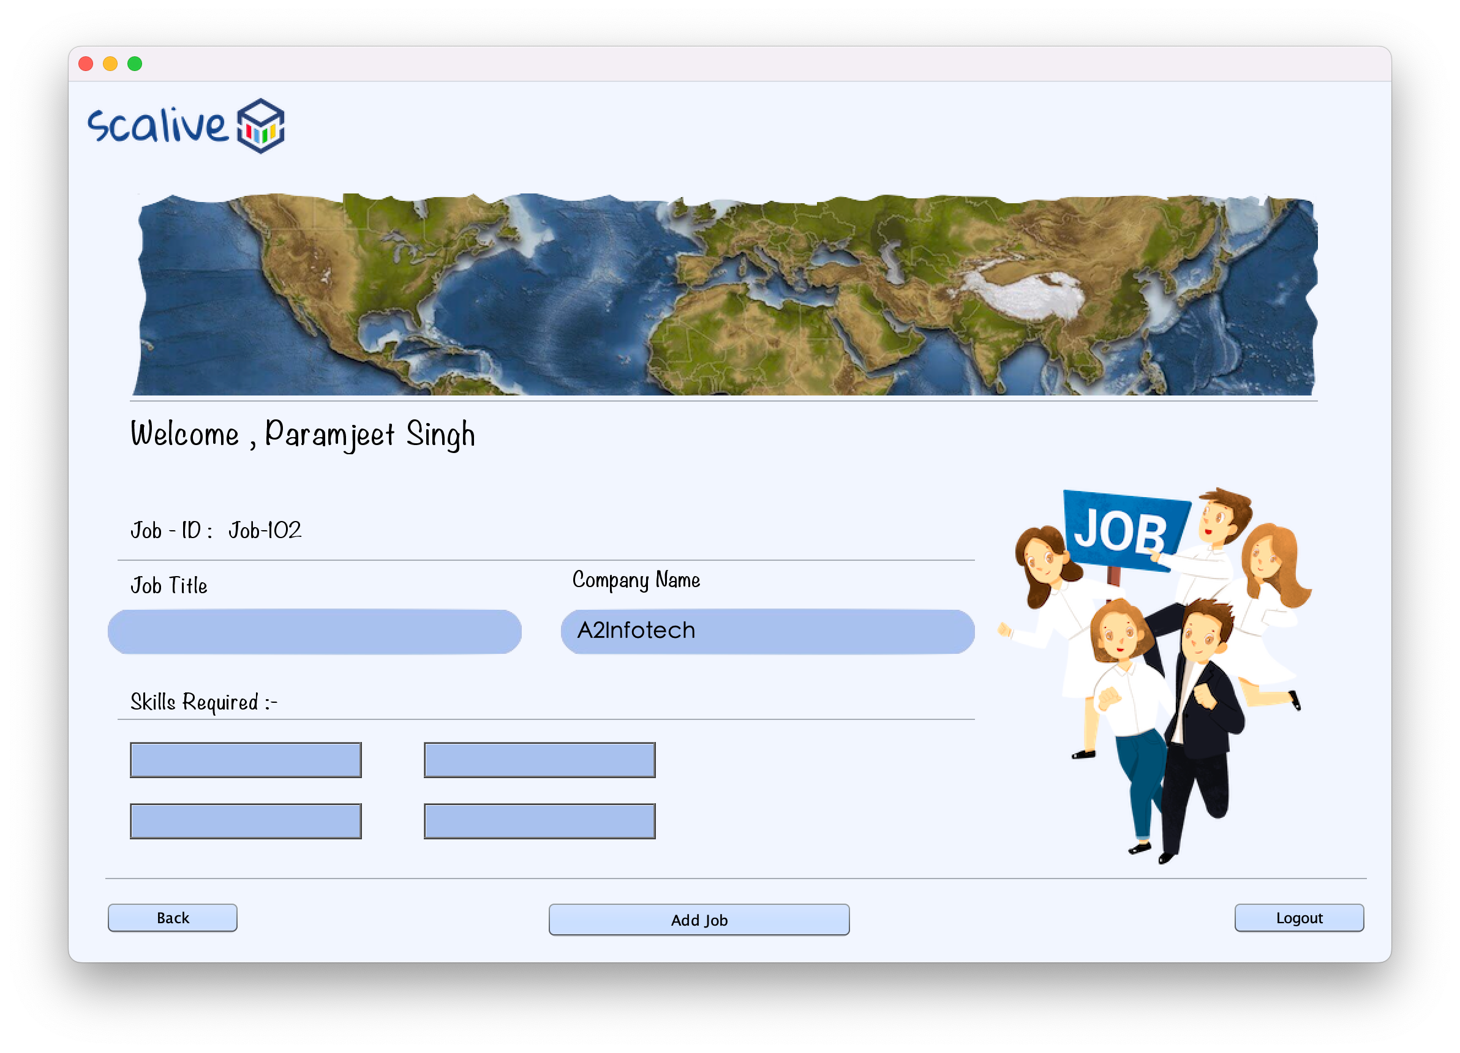Hr View all open job frame

Hr add new job frame

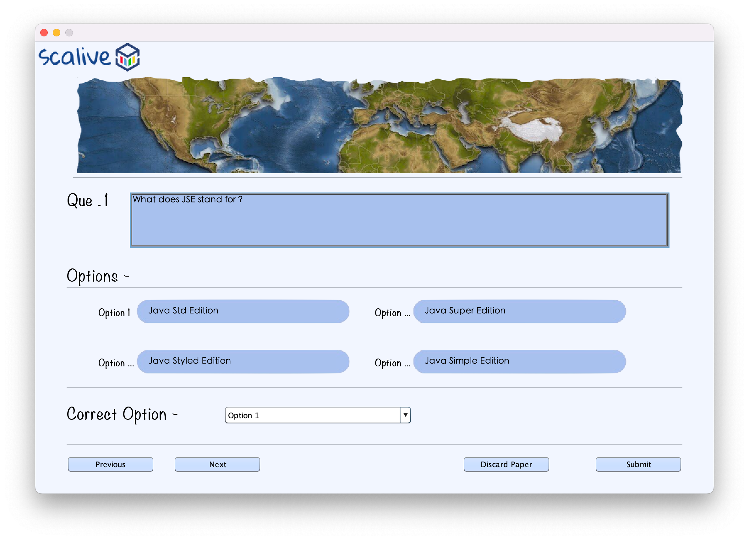

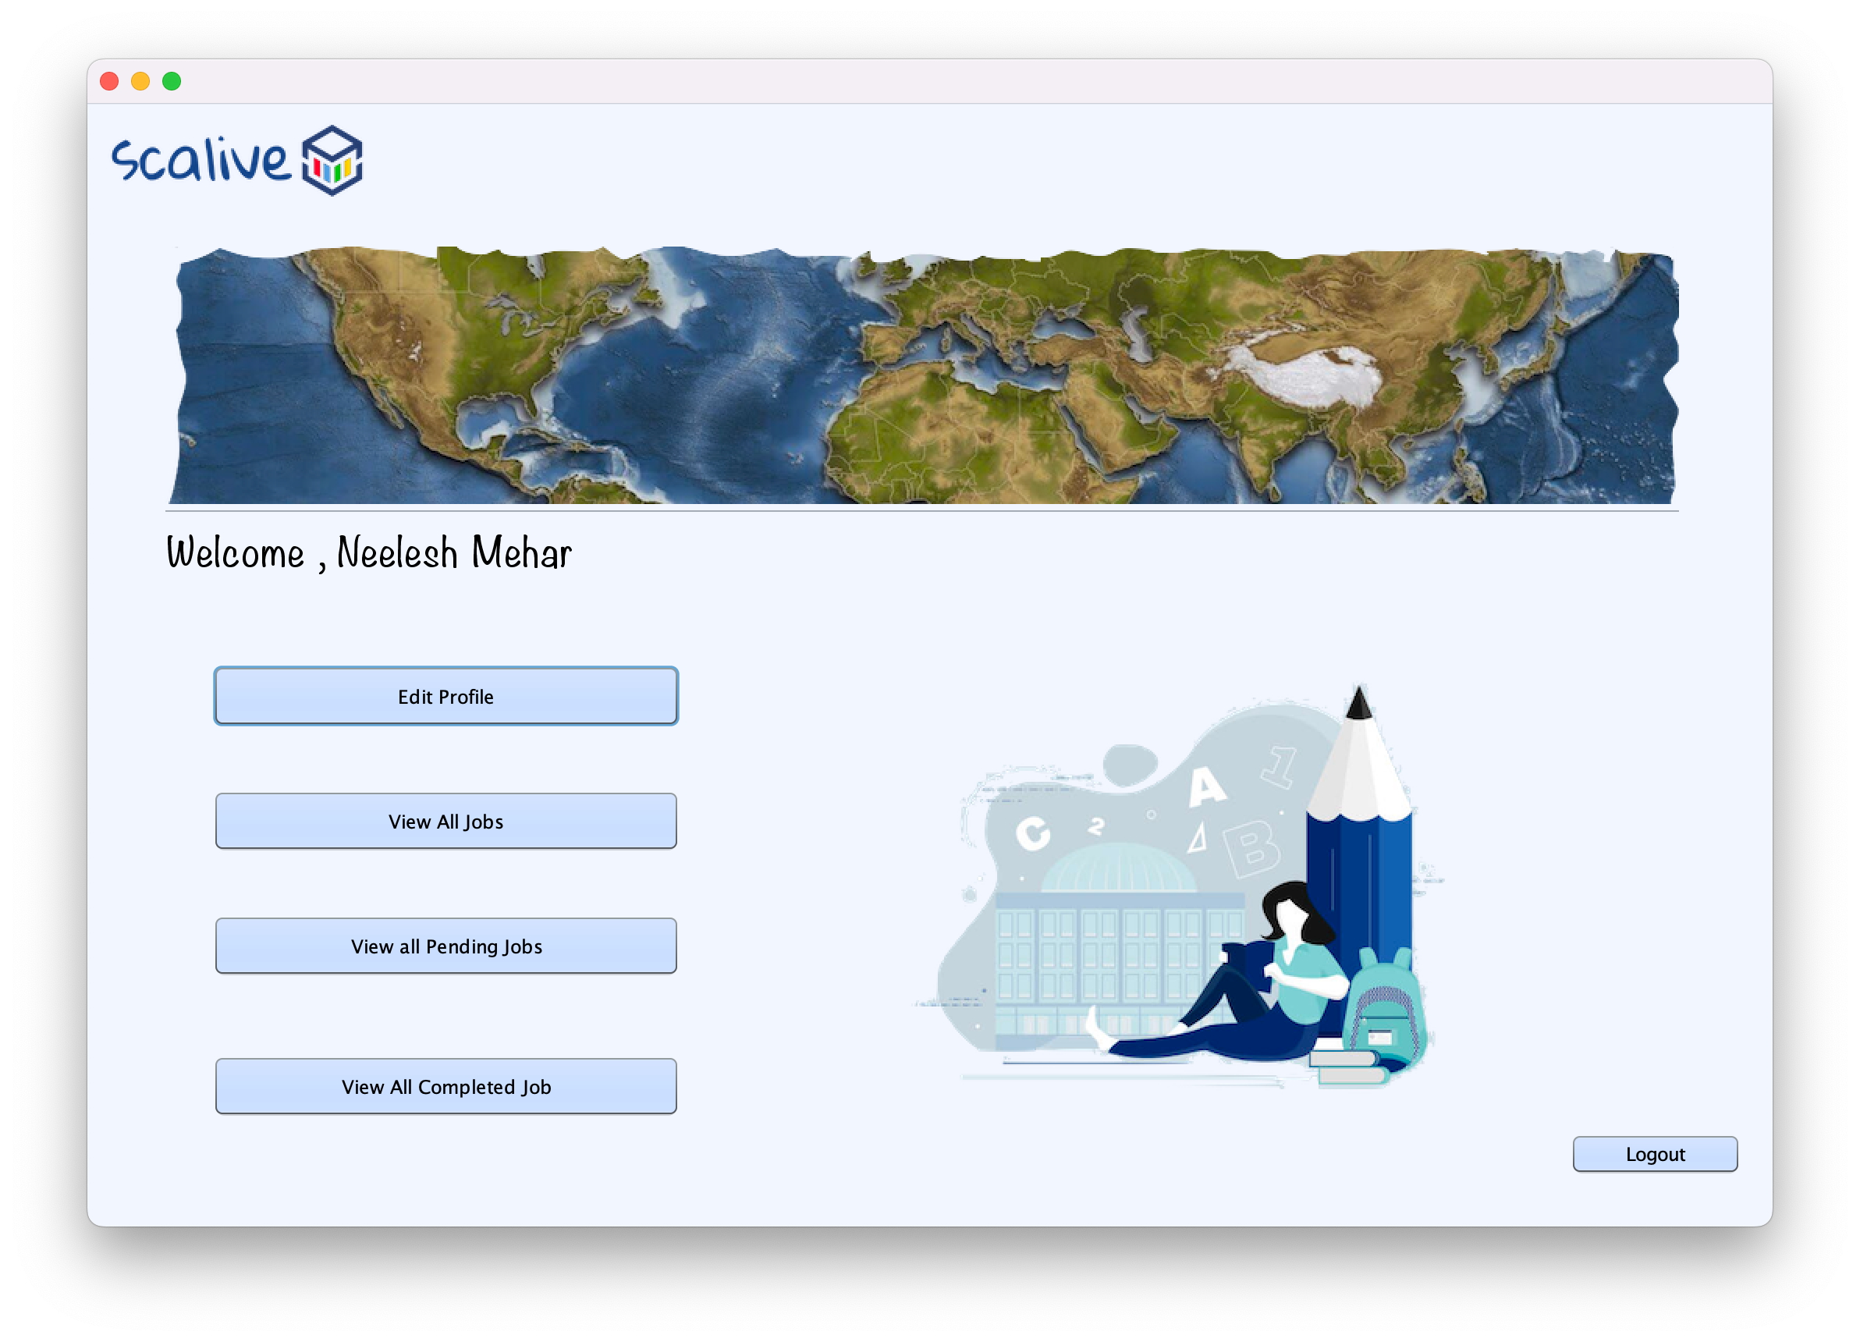Hr Set Quiz frame

Participants option frame

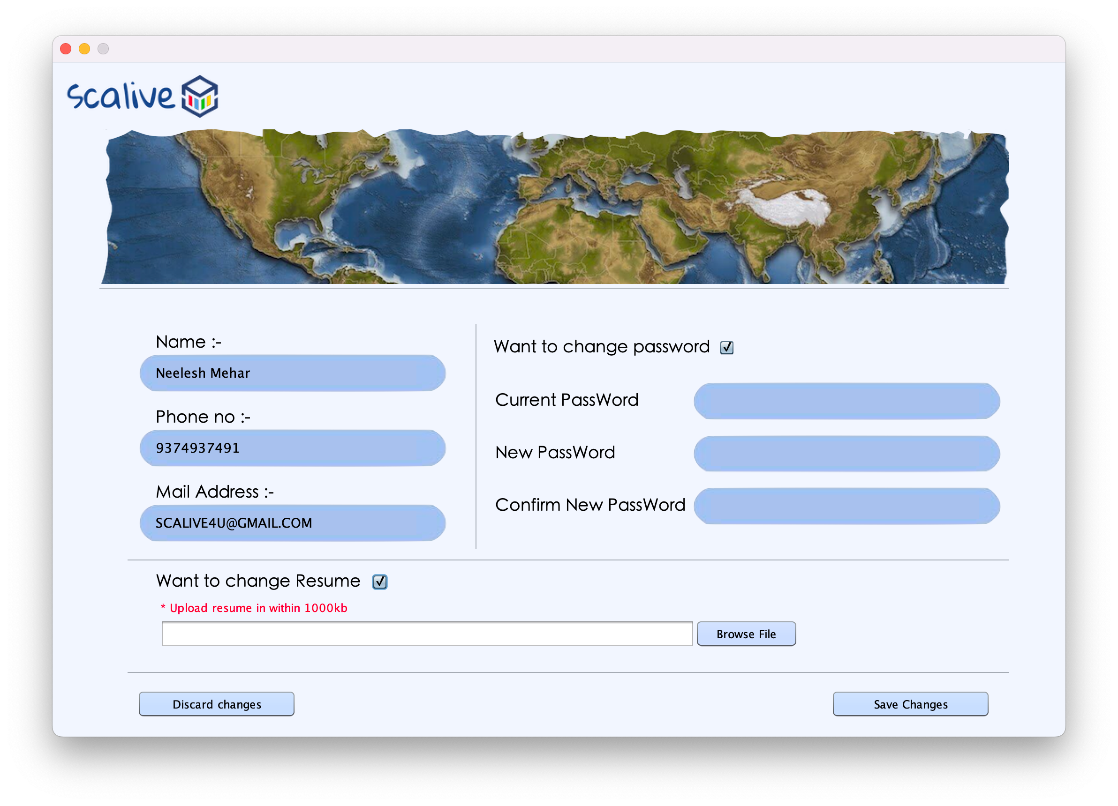

Participant edit profile frame

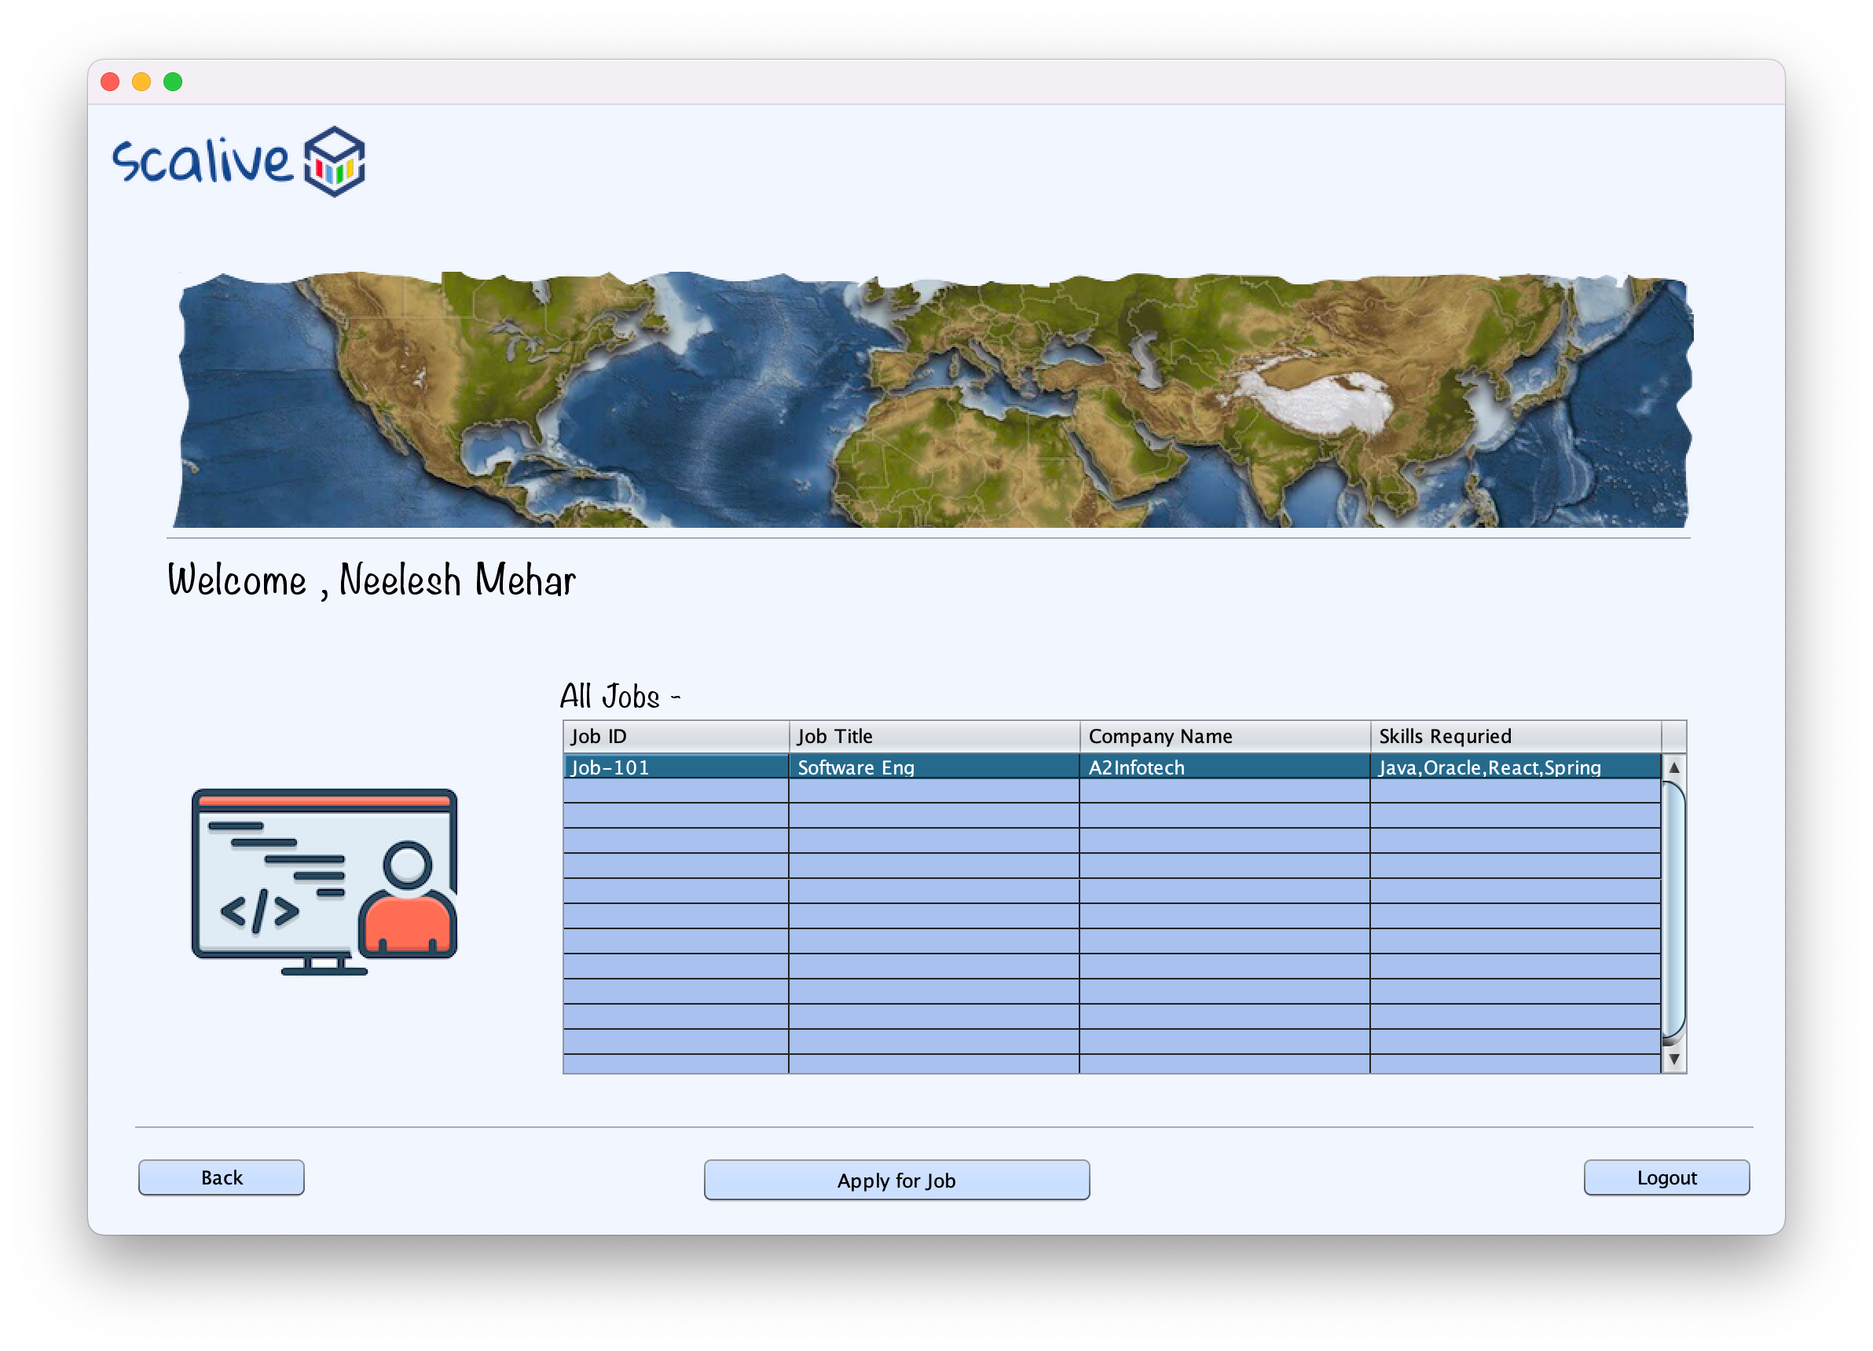

Participant view all job frame

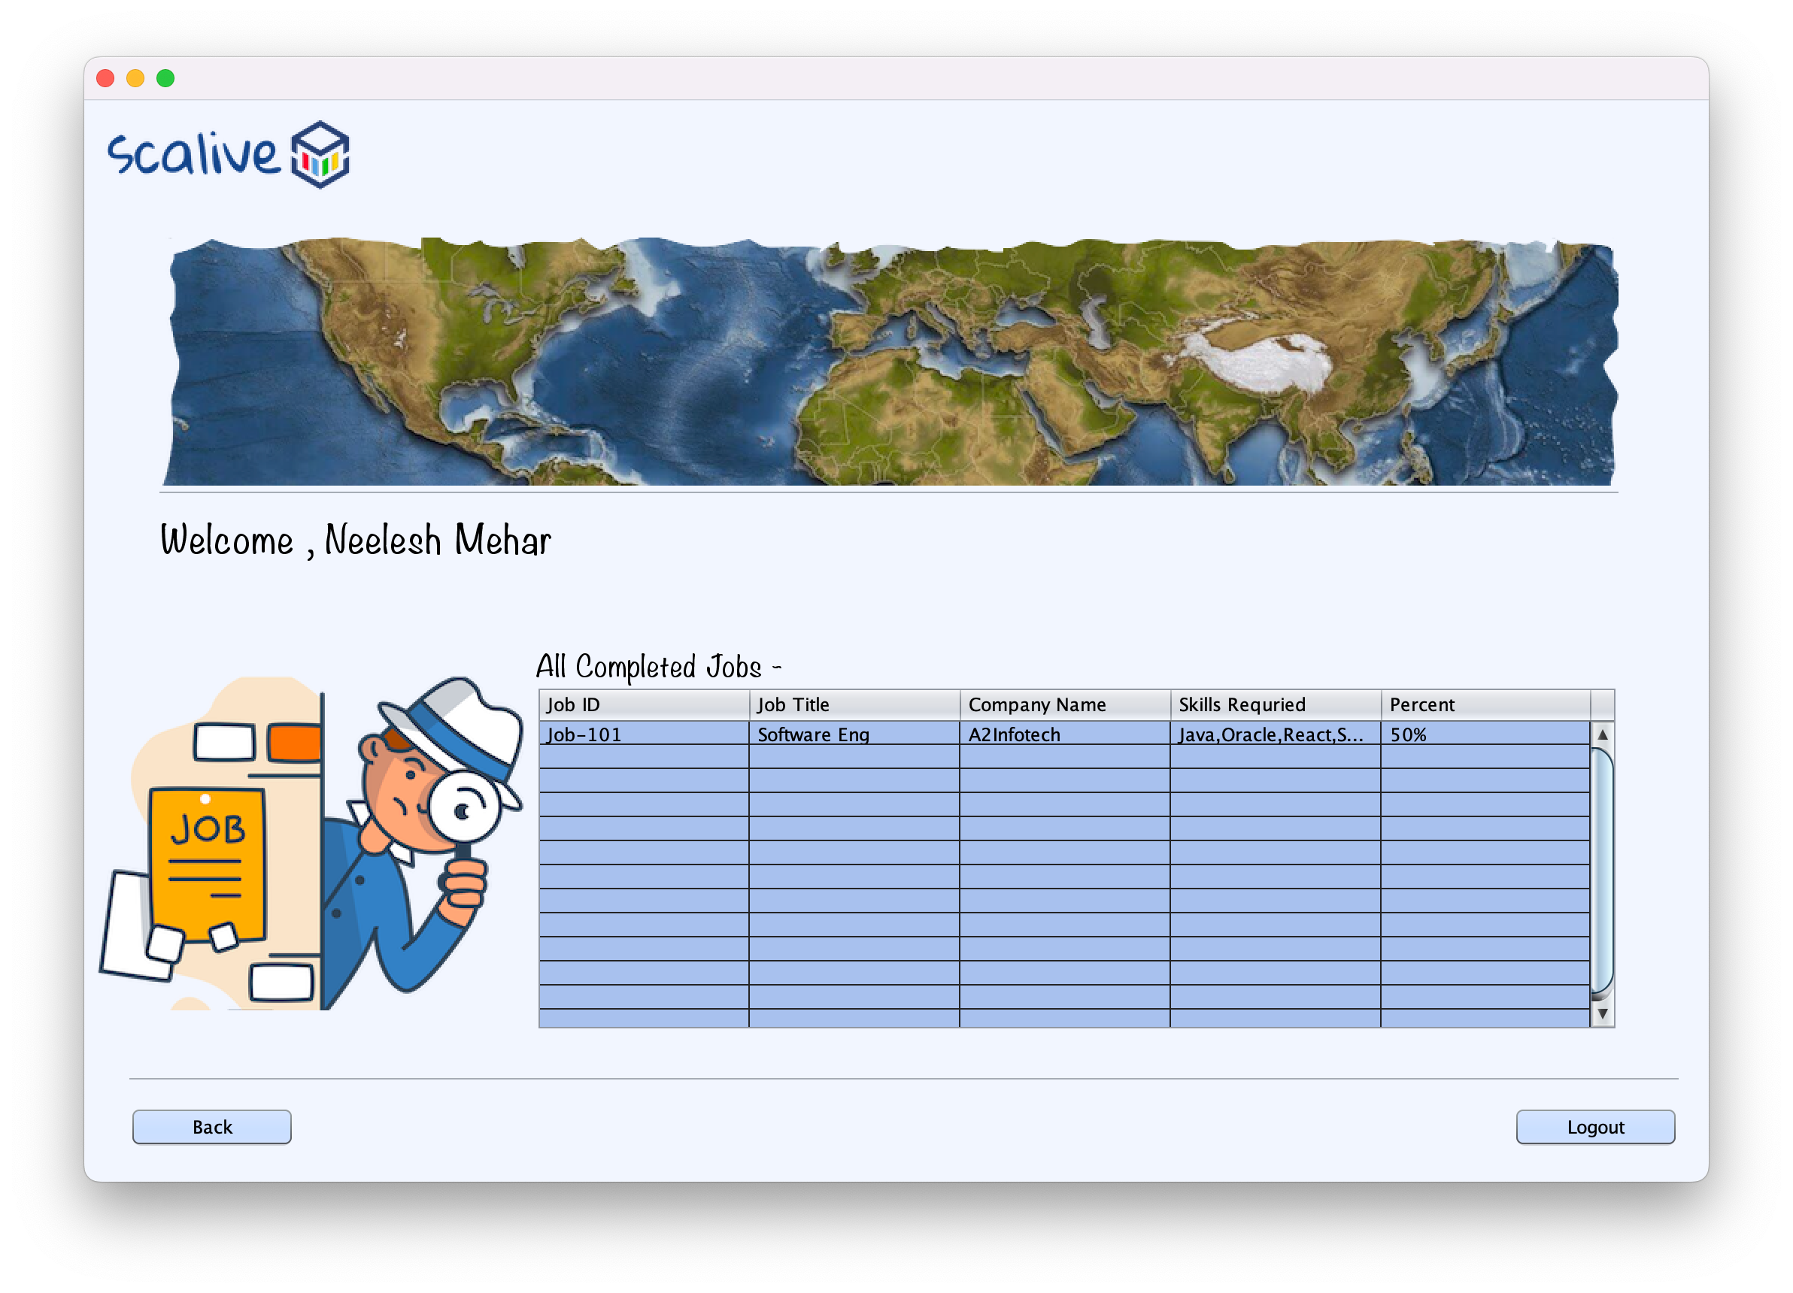

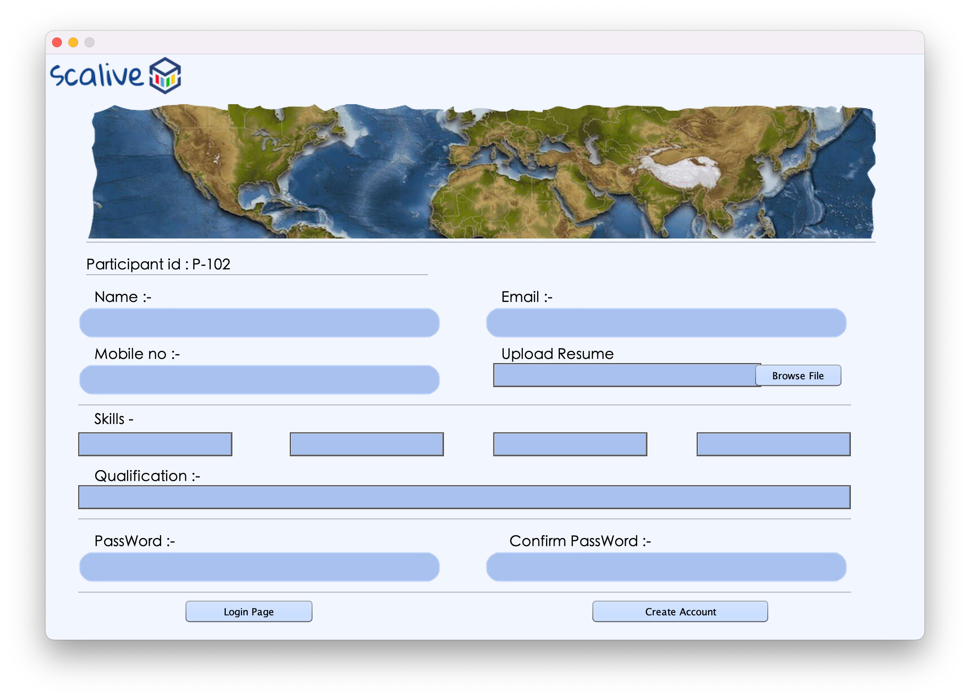Participant view all completed job frame

Sign up frame

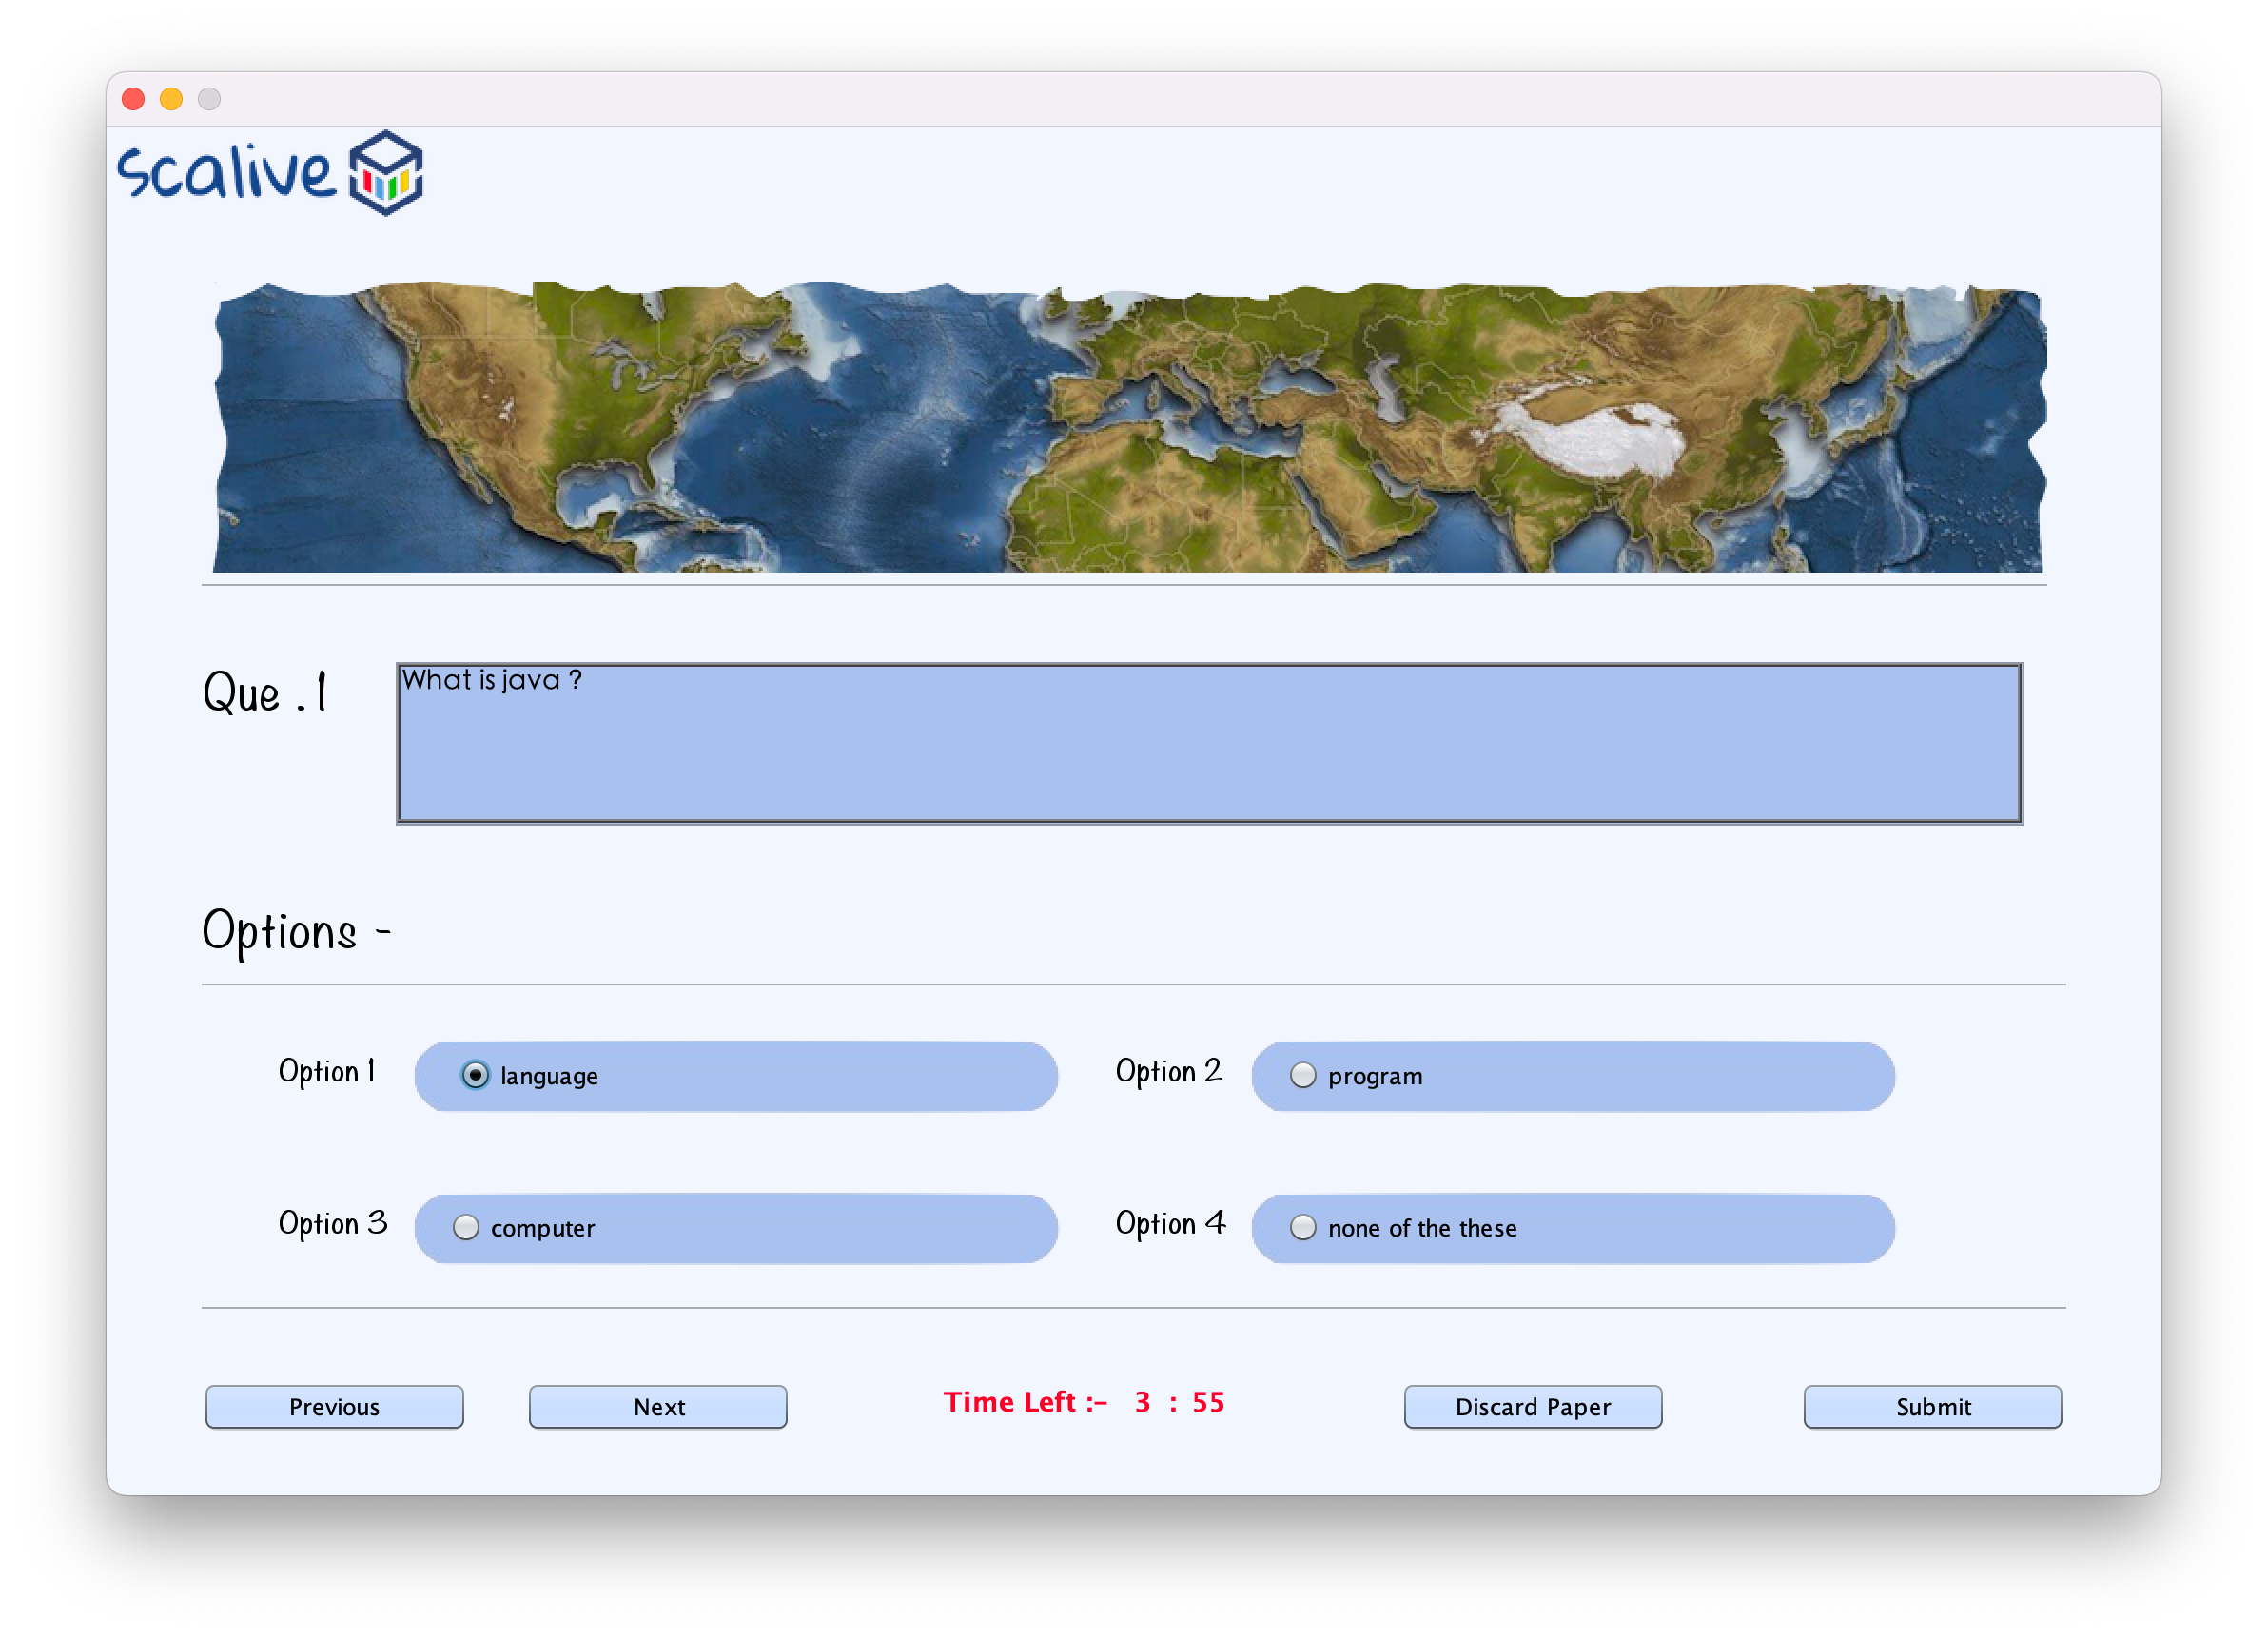

Participant take quiz frame